Honors Earth Science
Unit 5 Review Sheet
- Name and describe the two vertical zones of the ocean? | Photic – upper portion; abundant amount of life  Aphotic – Lower portion
- Compare seawater, freshwater and brackish water in terms of salinity. | Highest salinity = seawater  Lowest salinity = freshwater
- What is the largest type of stream? | River
- The location where two streams join together is known as a ___. | Confluence
- The point at which a stream originates is known as the ____. | Source
- The point at which a stream meets the ocean is known as the ___. | Mouth
- When does downwelling occur? | When very cold, very saline water sinks
- Where would an estuary be found? | Where a stream meets an ocean or lake
- Which small bodies of water have no outlet? | Ponds
- List and describe the three horizontal zones of the ocean. | - Littoral (intertidal) – area between the low and high tide marks  - Neritic – low tide mark to the continential shelf  - Oceanic – the rest of the ocean from the neritic zone outward
- Which state of matter does the majority of freshwater exist? | Solid
- If water can not flow through a rock, the rock is said to be ___. | Impermeable
- Why is upwelling important? | It brings nutrient rich water to the surface.
- Water is a polar molecule. What characteristic(s) does this give to water? | - Universal solvent
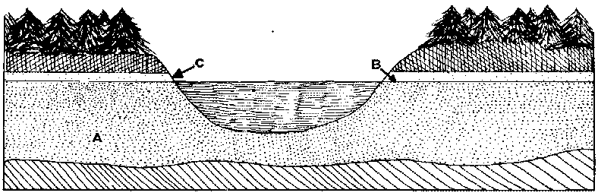

- Using the diagram above, label each of the zones.  - Zone a  - Zone b  - Zone c | Zone A is the zone of saturation  Zone B is the water table  Zone C is the zone of aeration
- The continuous movement of water around the Earth is known as the ___. | The hydrologic cycle
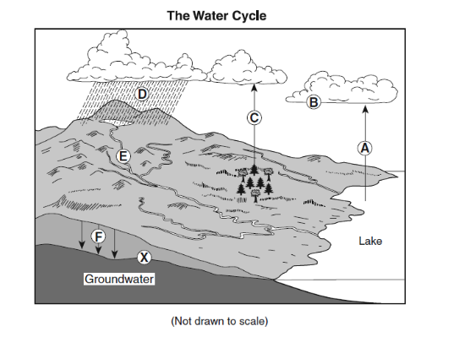
- What must happen before step D can occur? | condensation
- What process is happening at step C? | Transpiration
- Which step represents evaporation? | A
- Infiltration is represented by which step? | F
- Which step represents precipitation? | D
- What drives thermohaline circulation? | Differences in density
- What is the cause of deep ocean currents? | Sinking of denser water
- Where does the majority of freshwater exist? | Glaciers
- Describe rip currents | Currents that are close to shore that carry large amounts of water offshore quickly.
- Which type of water is the most dense? | Cold, salty water
- What motion do individual water molecules move in a wave in deep water? | In a circle
- What percentage of water on Earth is freshwater? | 3%
- What is the primary cause of tides? | The gravity of the moon
- What happens during transpiration? | Plants take in water from the soil and release it as water vapor into the atmosphere
- What causes the Coriolis effect? | The Earth’s rotation
- What type of water is brought to the poles by surface currents? | Warm
- What type of water is brought to the equator by surface currents? | Cold
- Ground water…..  - Renewable or nonrenewable  - Conserved by recycling used water  - Never used again once polluted  - Replenished by pumping saltwater into the ground | - Renewable  - Yes  - No  - No
- What is the amount of time a water molecule spends in a reservoir called? | Residence time
- Where does the Gulf Stream originate and where can it flow? | Originates in the Gulf of Mexico.  Flows up the east coast of North America, across the Atlantic ocean toward Great Britain and Europe
- List factors that influence infiltration of water into the ground | - Amount of vegetation  - The slope of the land  - The porosity and permeability of the rocks and soil  - The amount of rainfall in the region
- Most of the dissolved minerals carried into the ocean are _____. | Salts
- Ocean salinity would be high in areas where evaporation rates are _____ and water circulation is ______. | High  Low
- Water that is found in deep ocean currents of the Atlantic Ocean is described as _____ | Cold with a high salinity
- What do we call a body of water that has a current and is in constant motion? | A stream
- What conditions must be met in order for the water level in an aquifer to be held at a constant level? | The discharge and recharge rates must be the same.
- Explain the role the sun plays in the water cycle. | It provides the energy.
- Explain the movements of water through the hydrosphere. | Water enters the atmosphere through the processes of evaporation and transpiration as water vapor  Water is condensed in the clouds from a gas to a liquid.  Water falls back to the ground through the process of precipitation.  Water travels along the surface of the Earth as runoff.  Water enters the ground through the process of infiltration.
- How do spring tides differ from neap tides as far as the arrangement of the sun, moon and Earth? | Spring tides – sun, moon and Earth are all aligned.  Neap tides – the sun and moon are at right angles to each other with the Earth being in the middle.
- How do the tidal ranges differ during spring and neap tides? | During spring tides, the lowest low tides and the highest high tides exist. The tidal range is the greatest.  During neap tides, the differences in high and low tides is not that great!

