Biology Review Sheet  Cells: A Living System  Test Date = ____________________ | Name ___________________________________  Date __________________

Cells, Organelles, and Microscopes
- List the structures and/or organelles that could be found in a Plant Cell.
- List the structures and/or organelles that could be found in an animal cell.
- List the structures and/or organelles that could be found in a bacterial cell.
- List the 3 statements made in the Cell Theory | a.  b.  c.
- Which type(s) of organisms are classified as prokaryotes?

- Which type(s) of organisms are classified as eukaryotes?

- How are eukaryotic cells different from prokaryotic cells?

- How are eukaryotic cells similar to prokaryotic cells?

- What is the main function of the cell wall?
Where is the cell wall located in relation to the plasma membrane?

- Put the following words in order from smallest level to the largest level of organization in a multicellular organism:

tissue, organ system, cell, organ

- (a) Which organelle is responsible for making proteins?  (b) In which type(s) of cell(s) would you find this structure?  (c) Draw a cell with this structure labeled. | (a)  (b)  (c)
- (a) Which organelle is responsible for storing genetic information?  (b) In which types of cells would you find this structure?  (c) Draw a cell with this structure labeled. | (a)  (b)  (c)
- a) Which organelle is responsible for storing water and nutrients?  (b) In which types of cells would you find this structure?  (c) Draw a cell with this structure labeled. | (a)  (b)  (c)
- a) Which organelle is responsible for carrying out photosynthesis?  (b) In which types of cells would you find this structure?  (c) Draw a cell with this structure labeled. | (a)  (b)  (c)
- a) Which organelle is responsible for carrying out cellular respiration?  (b) In which types of cells would you find this structure?  (c) Draw a cell with this structure labeled.  (d) What is the advantage of the inner membrane of this structure being folded/curved? | (a)  (b)  (c)
- (a) Write the equation for photosynthesis.  (b) In which organelle does photosynthesis occur?  (c) What type of cell is capable of carrying out photosynthesis?  (d) Where do the reactants for photosynthesis come from?  (e) What happens to the products of photosynthesis? | (a)  (b)  (c)  (d)  (e)
- (a) Write the equation for cellular respiration.  (b) In which organelle does cellular respiration occur?  (c) What type of cell is capable of carrying out cellular respiration?  (d) Where do the reactants for cellular respiration come from?  (e) What happens to the products of cellular respiration? | (a)  (b)  (c)  (d)  (e)
- What gets “broken down” during cellular respiration so that energy can be made?

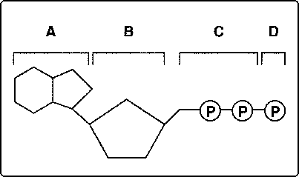  - (a) What does the structure drawn above represent?  (b) Where is energy stored in the molecule shown above?  (c) If structure “D” is removed, what is the name given to the molecule that exists?  (d) What can we compare this molecule to? | (a)  (b)  (c)  (d)
- (a) How is the genetic material of a eukaryotic cell similar to the genetic matieral of a prokaryotic cell?  (b) How is the genetic material of a eukaryotic cell different from the genetic material of a prokaryotic cell? | (a)  (b)
- (a) what is a plasmid made of?  (b) Which type of cell is a plasmid found in?  (c) Can a plasmid be transferred from cell to cell?  (d) Is a plasmid required for a cell to live? In other words, can a cell live without having a plasmid? | (a)  (b)  (c)  (d)
- (a) Draw a bacterial cell.
(b) Label each of the following in your drawing:
  - Cell wall
  - Plasma membrane
  - DNA
  - Flagella
  - Plasmid
  - Ribosome

18. How is the image seen with a scanning electron
microscope different from that seen with a light
microscope?

19. How is total magnification of a microscope
calculated?

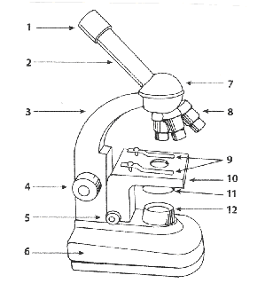  20. Using the diagram above,  - Which part of the microscope is used to move the stage up and down while focusing with the 4X (low) power? Give the number and the name.  - Where on the microscope would you find the lens that you look through? Give the number of the location and the name of that particular lens.  - Where on the microscope would you find the lenses that are closest to the specimen being viewed? Give the number location and the name of that particular lens. | (a)  (b)  (c)

Membranes and Transport
- (a) Draw an example of a cell that is in a hypertonic solution.  (b) What will happen to the water in this cell, will it move into or out of the cell?  (c) Will this cell shrink, get larger or stay the same?  (d) Which part of the egg lab does this resemble? | (a)  (b)  (c)  (d)
- (a) Draw an example of a cell that is in a hypotonic solution.  (b) What will happen to the water in this cell, will it move into or out of the cell?  (c) Will this cell shrink, get larger or stay the same?  (d) Which part of the egg lab does this resemble? | (a)  (b)  (c)  (d)
- (a) Draw an example of a cell that is in a isotonic solution.

(b) What will happen to the water in this cell, will it move into or out of the cell?

- Will this cell shrink, get larger or stay the same?

- Which part of the egg lab does this resemble?

- What is the function of the plasma membrane?

- Which type of transport requires the cell to use energy?

- Which type of transport does not require the cell to use energy?

- Fill in the following chart with the appropriate information:
 | Passive Transport | Active Transport
Energy Required?
High Low or
Low High
More even
Or
More uneven
Examples

- List the two molecules that make up the plasma membrane.
- (a) Draw a diagram that illustrates the structure of the plasma membrane.
(b) Label each of the following in your diagram:
  - Phospholipid
  - Phospholipid bilayer
  - Membrane protein
  - Hydrophilic head
  - Hydrophilic region
  - Hydrophobic tail
  - Hydrophobic region
- How is osmosis related to diffusion?

- (a) What happens to the molecules in a cell and the solution surrounding the cell once the concentration of the molecules on both sides of the membrane is the same?  (b) What type of solution is this? | (a)  (b)
- (a) What is homeostasis?

(b) Which cellular structure is responsible for maintaining homeostasis?
- What is the name given to a substance that helps to maintain an organisms pH level within a very narrow range so that homeostasis can be maintained?

Mitosis and the Cell Cycle

- How many daughter cells are produced by the process of mitosis?

- How do the daughter cells produced by mitosis compare to the parent cell?

- Which types of cells are produced by mitosis?

- What is the role of the spindle during mitosis?

- Describe what is happening in each of the cells shown below. Then put them in the correct order.
(a)
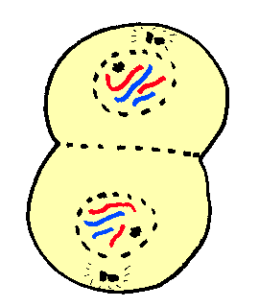

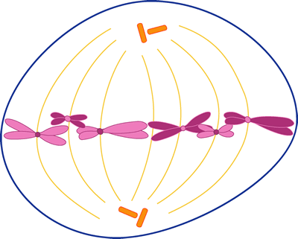

- 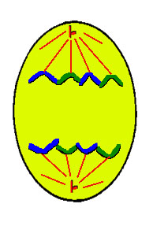
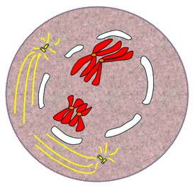

.
- (a) What are the three parts of interphase?  (b) List/Describe what happens during each  part of interphase. | (a)  (b)

Stem Cells
- What allows a stem cell to differentiate into unique types of cells?

- How is an embryonic stem cell different from an adult stem cell?

Cell Differentiation, Specialization and Adaptations

- What is the name given to the tail like projection that some unicellular organisms use to help them move through liquid?

- What is the name given to the structure an amoeba uses for locomotion/movement? They also use this same structure for feeding.
- (a) What is the function of the eyespot found in organisms like the euglena?  (b) What process is a euglena able to carry out that an amoeba is not able to carry out?  (c) Would the euglena use this for chemotaxis or phototaxis? Explain. | (a)  (b)  (c)
- What is the name given to the tiny hair like structures used by many unicellular organisms for movement? These structures move back and forth.

- By what process do cells become specialized to perform specific functions?

- What is being demonstrated when an organism avoids or moves toward a chemical?

- What makes it possible for a nerve cell to perform different tasks/functions from a muscle cell?

- (a) Do all of the cells in your body have the same DNA in them?  (b) Do all of the cells in your body have the same DNA “turned on”?  - Do all of the cells in your body perform the same function? | (a)  (b)  (c)
- (a) Describe the shape and structure of a red blood cell.  (b) Explain how the shape and structure of a red blood cells allows it to carry out the functions it carries out. | (a)  (b)

