Pre Biology: Students will have a fundamental understanding of basic science skills including:
- Utilization of proper lab safety procedures and tools
- Identification and correct usage of lab ware
- Application of the Scientific Method
- Proper experimental setup and procedure
- Evaluation and interpretation of experimental data

Lab Safety:
Equipment:
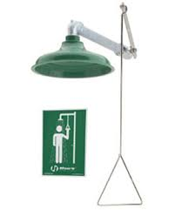  Name:  Use: |  | 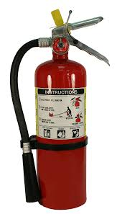  Name:  Use: |  |  | 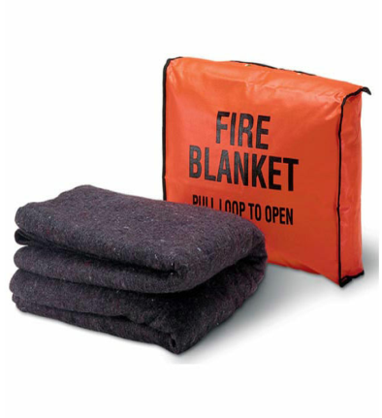  Name:  Use: |  | 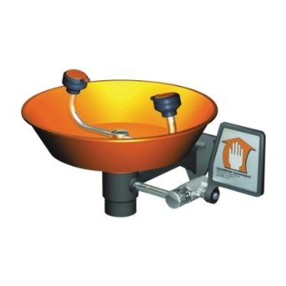  Name:  Use:
Rules in the biology lab:
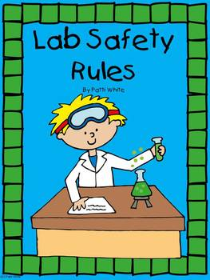
- Wash your hands.
- Wash your desk before and after experiments.
- Tell your teacher if anything spills or ____________________________.
- No monkey business or horseplay.
- ________________________________ carefully.
- Listen and follow directions.
- Handle animals with care and respect.
- Don’t Eat or Drink anything without permission
- Be careful with ____________________ or electrical appliances.
- Wear your _________________________________.
Lab Tools:
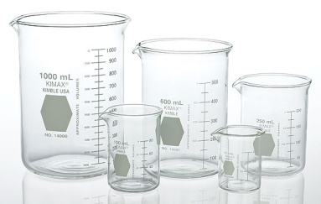  Name:  Use: |  | 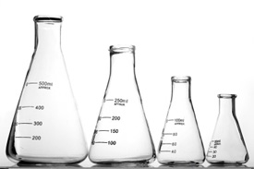  Name:  Use: |  |  | 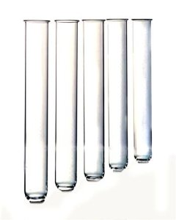  Name:  Use: |  | 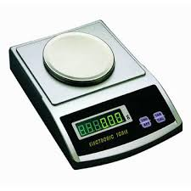  Name:  Use:
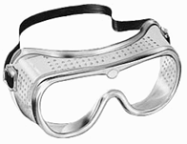  Name:  Use: |  | 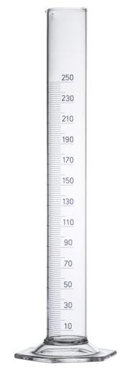  Name:  Use: |  |  | 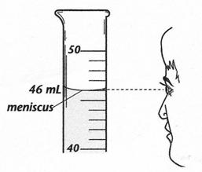  Name:  Use: |  | 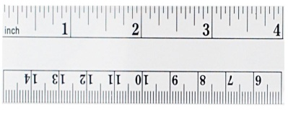  Name:  Use
Graphing:
Types of Graphs:
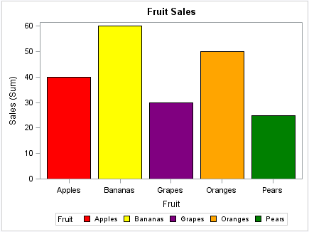  Name:  Used For: |  |  | 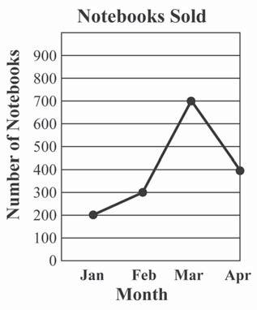  Name:  Used For: |  |  | 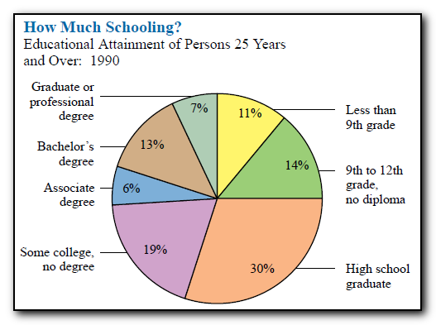  Name:  Used For:
Parts of Good Graph:
1. | 2. |  |  | 3. |  |  | 4.
Scientific Method:
Steps:
1. | 2.  Ways I Can Research My Problem: |  | 3.
4. | 5. |  | 6.
Observation |  | Inference
Experimental Design
Groups
Control Group |  | Experimental/Variable Group
Variables
Controlled Variables | Independent Variable |  | Dependent Variable
Data
Qualitative  - Deals with ___________________________________  - Data can be observed but not measured  - Colors, textures, smells, tastes, appearance, beauty, etc.  - Qualitative _____________________________________ |  | Quantitative  - Deals with ______________________________________  - Data which can be measured.  - Length, height, area, volume, weight, speed, time, temp.  - Quantitative ___________________________________

