Biology Lab  The Scientific Method using Magic Capsules | Name ____________________________  Date __________________
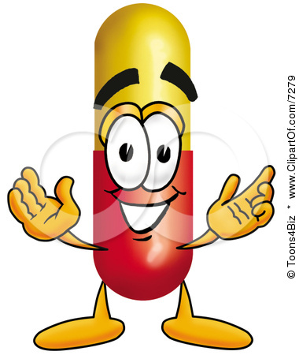
Materials Needed
- 2 Magic Capsules
- Warm water
- Cold water
- Two beakers
- Two plastic spoons
- Salt

Background:
In this lab you will be given two gelatin capsules that contain sponge animals which are common toys usually labeled as "magic capsules". The animals will grow when placed in water. Consider the following questions about the magic capsules.
- Does the temperature of the water affect the rate of growth?
- Does stirring the water affect the rate of growth?
- Does the type of water, salt or tap, affect the rate of growth?

The Experiment

- Choose one of the above questions and develop a hypothesis. Remember to state your hypothesis as an If/Then statement and make sure that it is testable. Fill this information in on the flow chart provided.

- Describe what your experiment will be like. In doing this, you need to decide the following:
- Independent Variable
- Dependent Variable
- Control Group
- Experimental Group

Fill this information in on the flow chart provided.

- Gather the materials needed and test your hypothesis.

- Record your data/observations on the flow chart provided.

- Write your conclusion on the flowchart. Your conclusion should answer the question posed in the hypothesis. Use your data/observations to support your conclusion.

