Notes: Pure Substances vs Mixtures
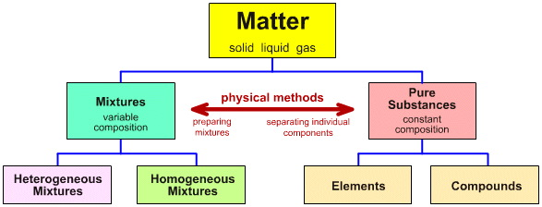
Elements:

- Can exist as either atoms (e.g. argon) or molecules (e.g. nitrogen)
- Cannot be broken down into a simpler type of matter by either physical or chemical techniques (though some larger elements break-down spontaneously due to being radioactive)
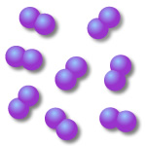
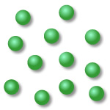

Example 1: Element existing in the form of atoms. Example 2: Element existing in the form of diatomic molecules (i.e. molecules formed from two atoms).
Compounds:

- Can be broken down into a simpler type of matter (elements) by chemical means; but not by physical means.
- Always contains the same ration of componenet atoms.
- Have properties different from their component elements
(e.g. the comound water (H₂O) is a liquid at room temperature and pressure and has different chemical properties from those of the two elements, hydrogen (H₂) and oxygen (O₂), rom which it is formed).
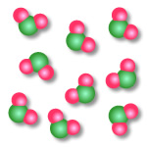
Example 1: Compound whose molecules consist of one atom of one element chemically joined with two atoms of another element.

Mixtures:

- Can be separated into their constituent parts by physical means.
- Have many of the properties of their constituent parts.
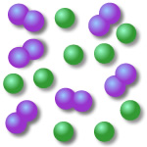
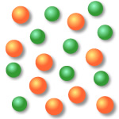
Example 1: Mixture of two elements, both of which exist as atoms rather than molecules.
Example 2: Mixture of two elements, one of which exists as atoms, the other as molecules.
Ex 2
Ex 1
Example 3: Mixture of two elements, both of which exist as molecules rather than atoms.
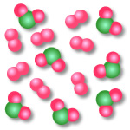
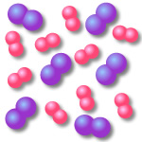
Example 4: Mixture of an element (that exists in the form of molecules) and a compound.
Ex 3
Ex 4
Separation Tcheniques:
Filtration:
- How it works:
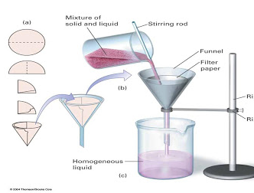

- Example: Sand and Water

Distillation:
- How it works:

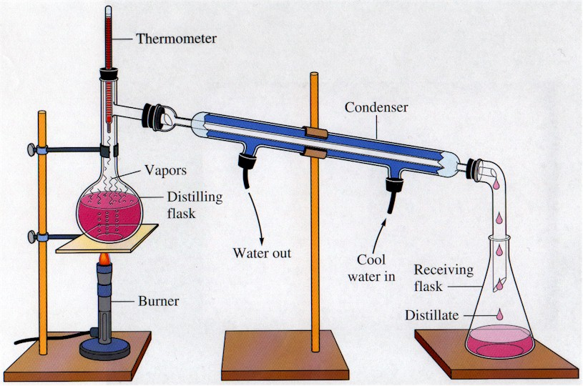

- Example: Water and Ethanol

Chromatography:
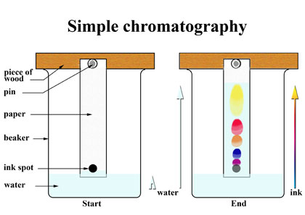
- How it works:

- Example: pigments in ink
- This is why ink “bleeds” on paper when it gets wet.
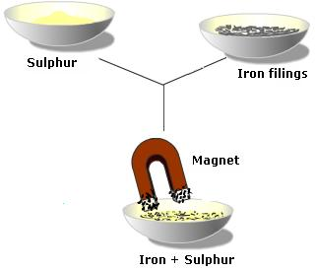
Using a Magnet:
- How it works:

- Example: Sulfur powder and iron filings
Crystallization:
- How it works:

- As one substance evaporates, the dissolved substance comes out of solution and collects as crystals
- Produces highly pure solids
- Example: Water and sugar (rock candy)

