Biology Review Sheet
Microscope, Cellular Organelles and Cell Differentiation

- Who looked at cork cells and gave cells their name? | 1.
- List the three statements of the cell theory. | 2 a.  b.  c.
- Does the cell theory apply to all cells?

- Which type of cells DO have a nucleus?

- Which type of cells do NOT have a nucleus?
- Which type of organisms are classified as prokaryotic?
- Which type of organisms are classified as eukaryotic? | a.  b.  c.  d.
- Where is DNA located in a cell? | Prokaryotic cell –  Eukaryotic cell -
- What carries the code to make proteins? Where is this found?

- Which part of the cell controls most of the cell’s processes?

- Which organelle breaks down food into molecules that the cell can use? This is cellular respiration.
- Which structure makes proteins?

- Would a mitochondria be found in a ……  - Bacterial cell?  - Animal cell?  - Plant cell? | (a)  (b)  (c)
- Which two organelles would you expect to find in plant cells but not animal cells? | (a)  (b)
- What is the main function of the cell wall?

- Which types of organisms do NOT have a cell wall?

- What is the function of the cell membrane?

- Put the following in the correct order from least complex to most complex: organ, tissue, cell, organism, organ system

- Put the following in order from least complex to most complex:
Circulatory system, cardiac cell, heart, cardiac tissue

- What is the name given to the area outside the nucleus but inside the cell membrane?

- Which cellular organelle is found in plants cells, green and makes food using the sunlight by the process of photosynthesis?
- Which cell structure is the powerhouse of the cell? This structure also is also where cellular respiration occurs. It breaks down food to release energy in the form of ATP.
- Which cellular organelle is responsible for storage?

- (a)Draw a prokaryotic cell.
(b) label each of the following in your drawing:
- Cell Wall
- Plasma membrane
- DNA
- Flagella
- Plasmid
- Ribosome
- Cytoplasm
- Pili

- (a) What is a plasmid made of?  (b) Which type of cell is a plasmid found in?  (c)Can a plasmid be transferred from cell to cell?  (d) Is a plasmid required for a cell to live? In other words, can a cell live without having a plasmid? | (a)  (b)  (c)  (d)
- How is the image seen with a scanning electron microscope different from that seen with a light microscope?

- (a) How is the genetic materials of a eukaryotic cell similar to the genetic material of a prokaryotic cell?  (b) How is the genetic material of a eukaryotic cell different from the genetic material of a prokaryotic cell? | (a)  (b)

- Which part of the microscope focuses an image under low power?

- What type of cell is pictured below?  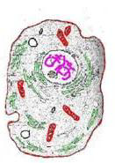  - Prokaryotic or Eukaryotic? How do you know this?  - Plant or Animal? How do you know this? |  | a.  b.
- Label all of the structures in the cell diagramed below  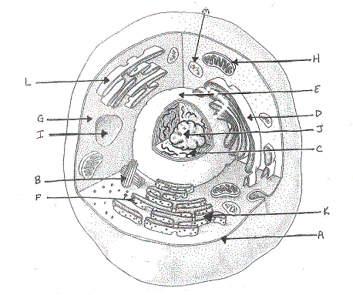  What type of cell is this? |  | a.  b.  c.  d.  e.  f.  g.  h.  i.  j.  k.  l.  m.
- What type of cell is pictured below?

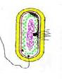
Prokaryotic or Eukaryotic?
How do you know this?

- How do you determine the total magnification of the microscope?

- Label all of the parts of the microscope  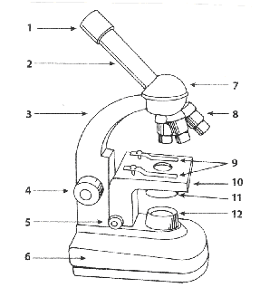 |  | 1.  2.  3.  4.  5.  6.  7.  8.  9.  10.  11.  12.
- What type of cell is pictured below?  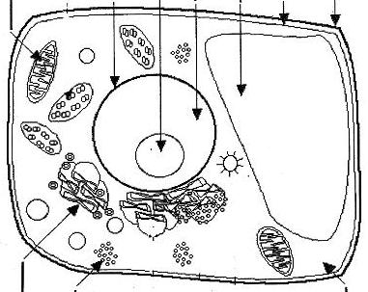  - Prokaryotic or Eukaryotic? How do you know this?  - Plant or Animal? How do you know this? | a.  b.
- Which part of the microscope regulates the amount of light that passes through a specimen?
- Which part of the microscope supports the slide being viewed?

- Which part of the microscope contains the ocular lens?

- Which part of the microscope would the low, medium and high powers be found on?
- Label the identified parts of the cell below:  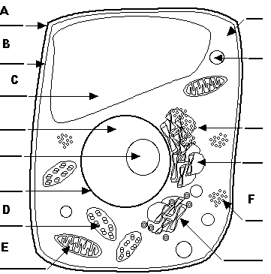  What type of cell is this? How do you know? | a.  b.  c.  d.  e.  f.

- Compare and contrast vacuoles in plant and animal cells.

- List 2 similarities and 2 differences between prokaryotic and eukaryotic cells.

- What is a stem cell?

- What allows a stem cell to differentiate into unique types of cells?

- By what process do cells become specialized to perform specific functions?

- What makes it possible for a nerve cell to perform different tasks/functions from a muscle cell?

- (a) Do all of the cells in your body have the same DNA in them?

(b) Do all of the cells in your body have the same DNA “turned on”?

(c)Do all of the cells in your body perform the same function?

- (a) Describe the shape and structure of a red blood cell.

(b) Explain how the shape and structure of a red blood cell allows it to carry out the functions it carries out.

