Honors Earth Science – Metric Conversions | Name ___________________________________  Date __________________
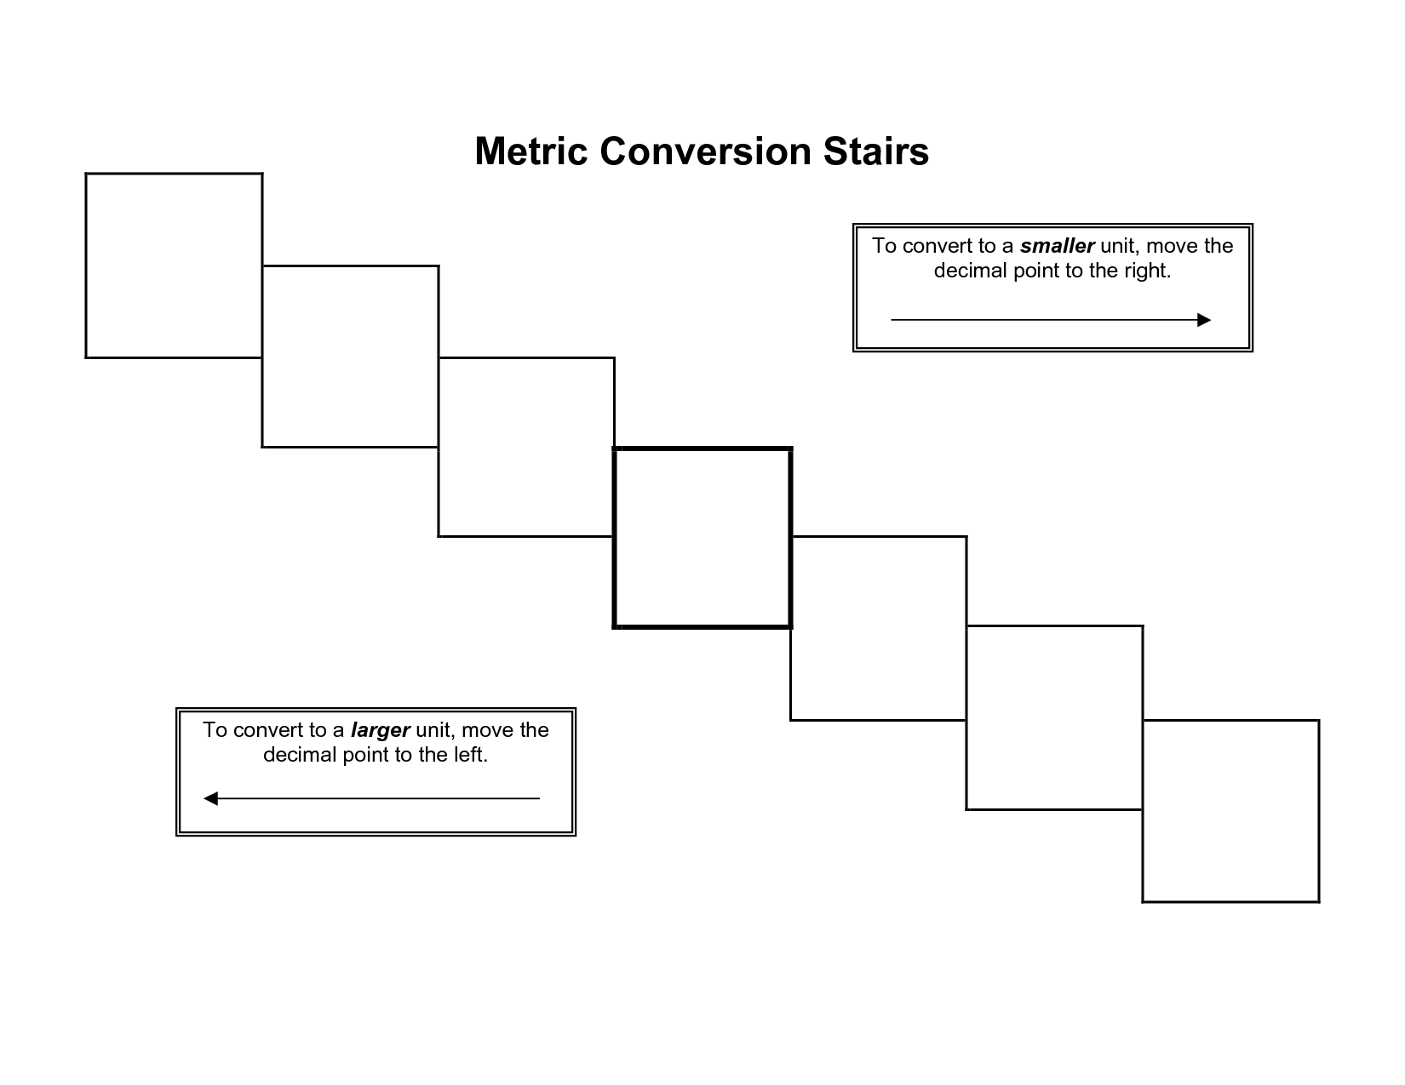

Use the above method to make the following metric conversions.

1. One human hair can support up to 3.01 Kg. That’s almost 7 pounds! Convert 3.01 Kg to Dg. ____________

2. It only takes 15, 400 grams of force or weight to rip off your ears. Convert this to Mg. ____________

3. In a hot climate, you can sweat as much as 11.355 Liters of water a day. Convert this to mL! ____________

4. A runner consumes about 795.2 centiliters (cL) of oxygen while running a 100-yard dash. Convert this into HL. _______

5. Dentists have recommended that a toothbrush be kept at least 1,834 mm away from a toilet to avoid germs hitting the
toothbrush resulting from the flush. Convert 1,834 mm into dm. ____________

6. It's physically impossible for you to lick your elbow, because it is 609 mm away from your mouth. Convert this into km.
____________

7. Over 25% of your old pillow – .044 Kg, to be exact – is made of old skin flakes, and the mites or “bed bugs” that eat the
skin! Convert .0044 Mg into cg. ____________

8. The average lead pencil, if sharpened with minimal loss of graphite, will draw a line 56.35 Km long or write approximately
50,000 English words. That’s 35 miles! Wow! Convert 56.35 Km into meters. ____________

