Biology Review Sheet  Membranes, Transport, Cell Cycle, Cancer and ATP  Test Date = ____________________ | Name ___________________________________  Date __________________

Membranes and Transport
- What is the name given to the stable internal environment that all cells need to maintain? | 1.
- What is the name given to substances that help a cell keep the pH the same? | 2.
- Describe the Fluid Mosaic Model of the cell membrane by answering the following questions:  - How many layers make up the cell membrane?  - What are these layers made up of?  - What are the channels that go through the membrane made up of?  - Which part makes the membrane fluid?  - Which part makes the mosaic of the membrane?  - Draw what we think the membrane looks like. | 3.  (a)  (b)  (c)  (d)  (e)  (f)
- What do we compare when we are trying to determine whether water is going to move into or out of a cell? | 4.
- List the two types of transport. | 5  (a)  (b)
- List the three types of passive transport. | 6  (a)  (b)  (c)
- (a) Draw an example of a cell that is in a hypertonic solution.  (b) What will happen to the water in this cell, will it move into or out of the cell?  (c) Will this cell shrink, get larger or stay the same?  (d) Which part of the egg lab does this resemble? | 7  (a)  (b)  (c)  (d)
- (a) Draw an example of a cell that is in a hypotonic solution.  (b) What will happen to the water in this cell, will it move into or out of the cell?  (c) Will this cell shrink, get larger or stay the same?  (d) Which part of the egg lab does this resemble? | 8(a)  (b)  (c)  (d)
- (a) Draw an example of a cell that is in a isotonic solution.  (b) What will happen to the water in this cell, will it move into or out of the cell?  - Will this cell shrink, get larger or stay the same?  - Which part of the egg lab does this resemble? | 9  (a)  (b)  (c)  (d)
- What is the function of the plasma membrane?

- Which type of transport requires the cell to use energy?

- Which type of transport does not require the cell to use energy?

- Fill in the following chart with the appropriate information:
 | Passive Transport | Active Transport
Energy Required?
High Low or
Low High
_{(which one)}
More even
Or
More uneven
_{(which one)}
Examples

- List the two molecules that make up the plasma membrane.
- (a) Draw a diagram that illustrates the structure of the plasma membrane.
(b) Label each of the following in your diagram:
  - Phospholipid
  - Phospholipid bilayer
  - Membrane protein
  - Hydrophilic head
  - Hydrophilic region
  - Hydrophobic tail
  - Hydrophobic region
- How is osmosis related to diffusion?

- (a) What happens to the molecules in a cell and the solution surrounding the cell once the concentration of the molecules on both sides of the membrane is the same?  (b) What type of solution is this? | 17(a)  (b)
- (a) By what process do single cell organisms take food INTO the cell?  (b) Is this an active or passive type of transport? (which one) | 18(a)  (b)
- (a) By what process do single cell organisms move waste OUT of the cell?  (b) Is this an active or passive type of transport? (which one) | 19 (a)  (b)
- What does it mean when we say a cell membrane is “selectively permeable”? | 20.
- Water and other substances tend to move from an area of ____ concentration to an area of _____ concentration during passive transport. | 21.
- During active transport, substances tend to move from an area of _____ concentration to an area of ______ concentration. This process requires the use of _________ in the form of ATP. | 22.

Mitosis and the Cell Cycle

- How many daughter cells are produced by the process of mitosis? | 1.
- How do the daughter cells produced by mitosis compare to the parent cell? | 2.
- Which types of cells are produced by mitosis? | 3.
- Name two cells that can NOT be produced by the process of mitosis. | 4.
- Describe what is happening in each of the cells shown below. Then put them in the correct order.  (a)  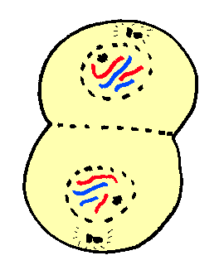  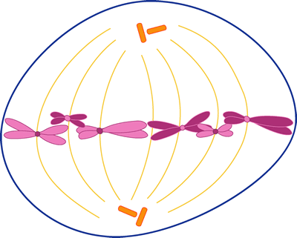  - 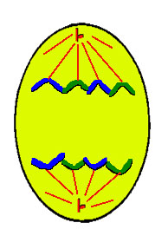  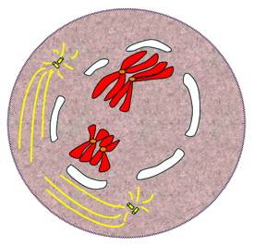  . | 5.  (a)  (b)  (c)  (d)
- (a) What are the three parts of interphase?  (b) List/Describe what happens during each  part of interphase. | 6(a)  (b)
- Does DNA replication/synthesis happen before or after mitosis? | 7.
- Which process produces more cells in your body when you are growing? | 8.
- What is another name for a body cell? | 9.
- Does the chromosome number change in cells that are produced by mitosis? | 10.
- What form is the DNA in when the cell is going through mitosis? | 11.
- What condition occurs when a cell has lost its ability to control the rate of mitosis? | 12.
- What is the spread of cancerous tissue called? | 13.

ATP
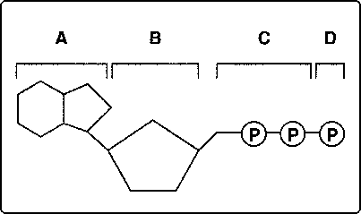  - (a) What does the structure drawn above represent?  (b) Where is energy stored in the molecule shown above?  (c) If structure “D” is removed, what is the name given to the molecule that exists?  (d)What can we compare this molecule to? | 1.(a)  (b)  (c)  (d)

