Lab Safety Equipment
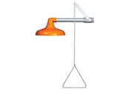  Name:  Use: | 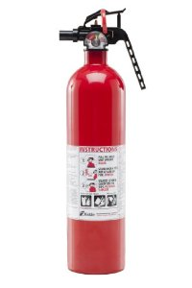  Name:  Use: | 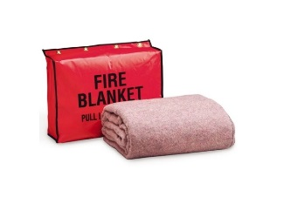  Name:  Use: | 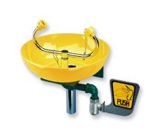  Name:  Use:

