Earthquakes
- How many seismic locations are needed to determine the epicenter of an earthquake?
- Which type of seismic wave…..
- does the most damage?
- Is the fastest?
- Moves back and forth
- Moves up and down
- Move up and down AND back and forth
- Move through the interior of the earth
- Move one the exterior of the earth
- Can move through solids only
- Can move through solid, liquid or gas
- What follows a major earthquake?

- Which of the scale uses eyewitness description of earthquake activity to determine the strength of the earthquake?
- What is the highest magnitude possible on the Richter scale?

- What type of fault system is the San Andreas fault?

- What is the name of the instrument used to measure an earthquake?

- What do scientists measure in order to determine the epicenter of an earthquake?

- Name the situations in which an earthquake can form.

- What are some of the things that can cause death during an earthquake?

- What is formed at a diverging boundary?

12.What is formed at a converging boundary?
Think about all three scenarios.

13.What is formed at a transform boundary?

14. What type of plate boundary, fault and stress
is illustrated below?

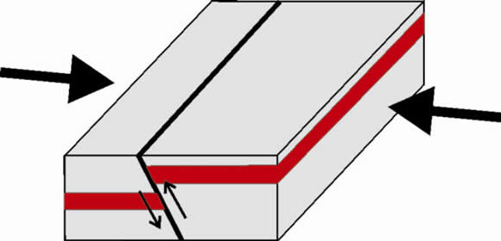

15. What type of plate boundary, fault and stress is illustrated below?
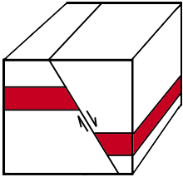
16. What type of plate boundary, fault and stress is illustrated below?
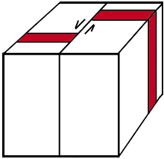
17. What are the types of evidence that scientists use to predict earthquakes? Be able to explain them.

18. What materials are the best to use when building a structure in an earthquake prone area? Why?

Volcanoes
- What is viscosity?

- Where do most volcanoes occur?

- What type of plate boundaries do we have here in NC?
- How are lava and magma different?

- What is volcanic activity in the middle of a plate called?
- What is the material that is thrown up into the air during a volcanic eruption?

- What is the rapidly moving gas that erupts from a volcano?
- What’s the opening of a volcano called?

- On what type of geological structure did the Hawaiian islands form?

- Where is the most geographically active region of the Earth is located?

- How is a geyser created?

- What is a dormant volcano? How is it different from an active one? How is it different from an extinct one?

- What type of lava is associated with each of the following:
- Composite volcano?
- Shield volcano?
- Lava dome
- Lava plateau
- Cinder cones
- When are pillow lavas formed?

- When are a’a lavas formed?

- Which type of volcano is…
- The most common type
- The most dangerous type
- The most gentle type
- Has gently sloping sides
- A small volcano with steep sides
- Mauna Loa
- Mt Fuji

