Biology Review Sheet
Basic Science Skills Unit
Test Date = ___________________________

- List situations that could occur during a lab in which you should notify the teacher.
- Which piece of safety equipment would you use to….
- Put out a fire in the trash can
- Put the fire out that has erupted on your lab partner
- Get chemicals out of your eyes
- What is ONE safety rule you should ALWAYS follow?
- Should you ever “guess” about what steps you should take during a lab if you are unsure or in doubt about any part of a lab?
- List the steps of the scientific method in order.
- What do we call information that we gather during an experiment?
- When you suggest that warm water will melt snow and ice, you have made what type of statement?
- Is/can a hypothesis….  - Ever proven?  - Accepted as correct with being tested with an experiment?  - Be disproven by a single experiment? | a.  b.  c.
- When is a hypothesis useful?

- What is the purpose of an experiment?

- How many trials/samples for each experimental group should be tested during an experiment that is using a good experimental design?
- How many variables are tested in a controlled experiment?
- Use the following picture to answer questions differentiating qualitative and quantitative data:  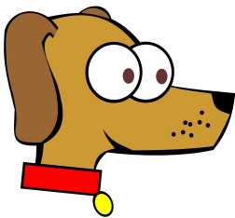  - Fido has big eyes.  - Fido has two eyes.  - Fido has one nose.  - Fido has a long nose.  - Fido has a wide collar | a.  b.  c.  d.  e.
- Use the following diagram to determine whether each statement is an Inference or an Observation.  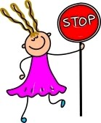  - She is holding a stop sign  - It is windy outside  - She is wearing a dress  - She is happy  - She is working at a cross walk.  - There are four letters on the sign.  - Her mom made her pancakes for breakfast. | a.  b.  c.  d.  e.  f.  g.
- What is information gathered by using one of the five senses called?

- When we use numbers to describe objects, we are being _______.

- When we use words/descriptions to describe objects, we are being _____.

- What is the act or process of deriving a conclusion based solely on what one already knows called?

- Which variables are…  - Observed to measure a change as a result of the independent variable?  - Graphed on the y-axis?  - Controlled and changed by the person conducting the experiment?  - Graphed on the x-axis? | a.  b.  c.  d
- List all of the steps that you need to follow when labeling a graph. Remember “TAILS DRY MIX” | T.  A.  I.  L.  S.  D.  R.  Y.  M.  I.  X.
- Which part of the scientific method is stated as an “If, then” statement?

- Which part of an experiment is changed by the experimenter?

- Which part of an experiment is measured or the outcome?

- Which group in an experiment gets the “special treatment”?

- Which group in an experiment does not get the “special treatment”? This group is used for comparison.
- Use the following data chart to answer the questions listed after the chart:  Number of Baskets Made by FVHS Basketball Team  Group 1 Baskets Made Group 2 Baskets Made  Day 1 55 40  Day 2 58 45  Day 3 62 48  Day 4 62 50  Day 5 65 53  Day 6 66 54  Day 7 69 59  - On which day did Group 1 make 10 more baskets than Group 2?  - On which day did Group 2 make 50 baskets?  - How many days did Group 1 make 62 baskets? | a.  b.  c.
- What unit do we use in Biology when we are measuring mass?

- Which piece of lab equipment is used to most accurately measure volume of a liquid?

- Which part of an “If, then” statement is the independent variable?

- Which part of an “If, then” statement is the dependent variable?

- Which piece of lab equipment would you use to measure the mass of an object?

- What is the use of this piece of lab
equipment?

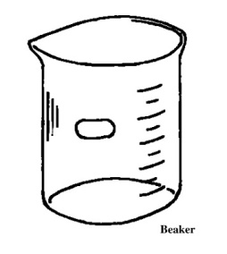

- What is the use of this piece of lab
equipment?
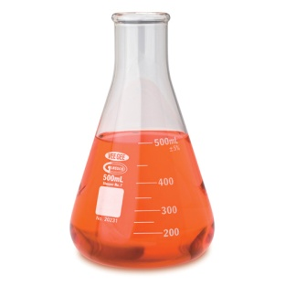

- What is the use of this piece of lab
equipment?
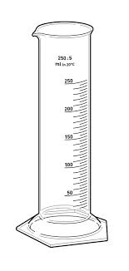

- What is the use of this piece of lab
equipment?
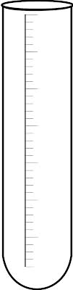
- What is the use of this piece of lab
equipment?
