Bio.4.1 Understand how biological molecules are essential to the survival of living organisms.
Bio.4.1.1 Compare the structures and functions of the major biological molecules (carbohydrates, proteins, lipids, and nucleic acids) as related to the survival of living organisms.
Bio.4.1.2 Summarize the relationship among DNA, proteins and amino acids in carrying out the work of cells and how this is similar in all organisms.
Bio.4.1.3 Explain how enzymes act as catalysts for biological reactions.
Bio.4.2 Analyze the relationships between biochemical processes and energy use in the cell.
Bio.4.2.1 Analyze photosynthesis and cellular respiration in terms of how energy is stored, released, and transferred within and between these systems.
Bio 4.2.2 Explain ways that organisms use released energy for maintaining homeostasis (active transport).

4 Biological MOlecules
Any compound that contains ______________________________________________

_______________________________________: A large molecule formed when many small molecules bond together. | 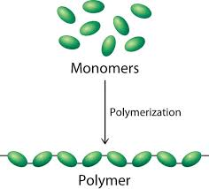
_______________________________________: Small molecules that make up a polymer

- Carbohydrates (Polymer) ____________________________________________(monomer)
- Use: Provides cell with ________________________________________________________________________

Two Types
- Simple Carbohydrates | - Complex Carbohydrates
____________________________& ______________________________ | ___________________________________________________________
- Taste: Sweet-tasting Carbs | - Taste: Starchy Carbs
- Food Examples Found in my refrigerator: | - Food Examples found in my refrigerator:
- Examples of monosaccharides:  - Examples of Disaccharides: | - Glycogen:
 | - Starch:
 | - Cellulose:
- Carbohydrate Tests
2 Tests
Monosaccharides | Polysaccharides
_____________________________________________ Solution  Negative Test:  Positive Test: | ___________________________________________ Test  Negative Test:  Positive Test:
2. Lipids (Polymer) ____________________________________________________ (monomer)

- Do Not ________________________________________ in water
- Use: Serve as cell’s _________________________________________________________ & _________________________________________.
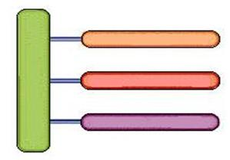  - Structure | - Lipid Test  _________________________________________________ Test  Negative Test:  Positive Test:
- Food Examples found in my refrigerator: | - Other examples of lipids:  - Phospholipids:  - Steroids
3, Nucleic Acids (Polymer) ________________________________ (Monomer)

- Use: Carries ________________________________________________________________________ in the form of ______________________.

Two Types of Nucleic Acids
DNA |  | RNA
3 Differences  - Structure  - Bases  - Sugar |  | - Structure  - Bases  - Sugar
- Structure of a Nucleotide  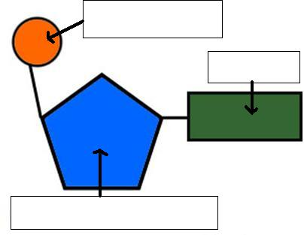 |  | - Food Source:  Any and all _________________________________________________
 |  | - Nucleic Acid Test:
4, Protein (Polymer) ________________________________ (Monomer)

Use: Provides __________________________________________ for tissues and organs

Proteins are specialized based on how they ____________________  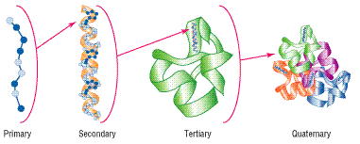 |  | - Protein Test:  _________________________________________________ Test  Negative Test:  Positive Test:
 |  | - Examples of Proteins (End in –in)
 |  | - Examples of Proteins found in my refrigerator:
Enzymes: Proteins that speed up chemical reactions(__________________________________________________________________________) by lowering the ____________________________________________________________________.
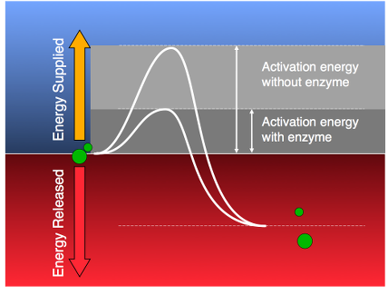 |  | Enzymes have names that end in _-___________________  And are ___________________________ & _______________________  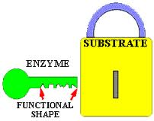
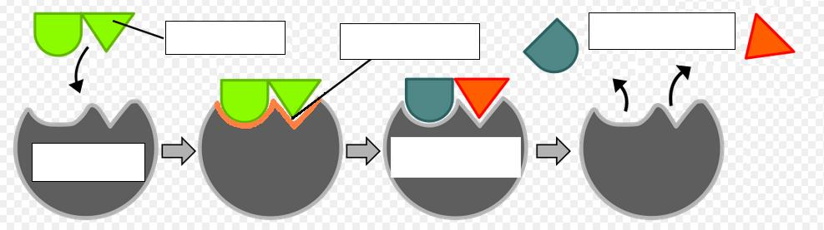

Enzymes are affected by 2 things
Temperature |  | pH
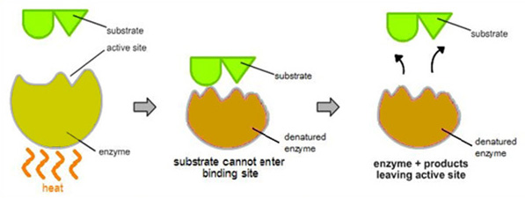  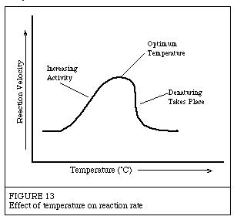 |  | 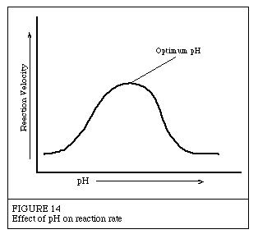  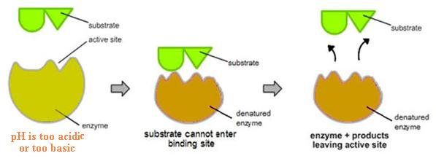
What is pH?
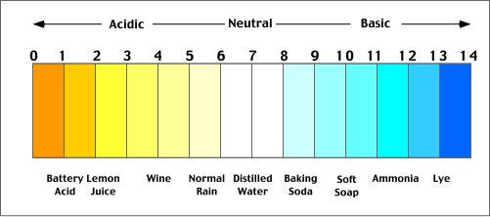

Extreme Temperatures and/or pH Can _________________________________________________________ an enzyme!!

Biochemical Processes and Energy Use
Photosynthesis:
Reactants  _______________________ + ______________________ + _____________________ |  |  | Products  ___________________ + _____________________
Equation

Occurs in the ______________________________________________  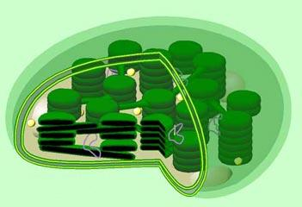 |  | Factors that Affect the rate of Photosynthesis:  1.  2.  3.  4.
Cellular Respiration
Reactants |  | Products
________________________ + ______________________ | _____________________ + _____________________ + __________________
Equation

Occurs in the ____________________________________________
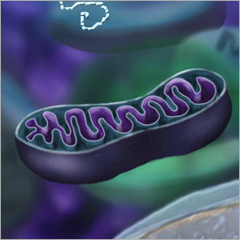

There are 2 kinds of Cellular Respiration
Aerobic |  | Anaerobic  (A.K.A) “Fermentation”
Breaking down _________________________________ to get energy in the presence of _______________________. |  | Breaking down _________________________________ to get energy in the absence of ___________________________________.
Produces ________________ ATP (___________________) |  | Produces only ___________________ ATP (Not __________________)
 |  | Alcoholic Fermentation |  | Lactic Acid Fermentation
 |  | - Small Organisms ( ) |  | - Larger Organisms ( )
 |  | - Makes ethyl __________________ instead of water |  | - Makes _______________________ instead of water
 |  | - Examples: |  | - Makes us ____________________ when we work out.
What do organisms do with this energy?

______________________________________________________________________________________!!!

- ______________________ | - ______________________ |  | 3. _________________________ |  | 4. _______________________

