Bio.3.4 Explain the theory of evolution by natural selection as a mechanism for how species change over time.
Bio.3.4.1 Explain how fossil, biochemical, and anatomical evidence support the theory of evolution.
Bio.3.4.2 Explain how natural selection influences the changes in species over time.
Bio.3.4.3 Explain how various disease agents (bacteria, viruses, chemicals) can influence natural selection. Bio.3.5 Analyze how classification systems are developed upon speciation.
Bio.3.5.1 Explain the historical development and changing nature of classification systems.
Bio.3.5.2 Analyze the classification of organisms according to their evolutionary relationships (including dichotomous keys and phylogenetic trees).

Early Earth & First Life
Biogenesis:  The theory that all life comes from ___________________________ life.  **Accepted!**  Describe the conditions of Early Earth:  Gases in Early Earth’s atmosphere:  Oparin’s Theory  ________________________________ (Sun & Lightning)  + ______________________________(methane, ammonia, Hydrogen)  =__________________________________________  Miller & Urey  Tested Oparin’s theory with this machine! Oparin was RIGHT!!  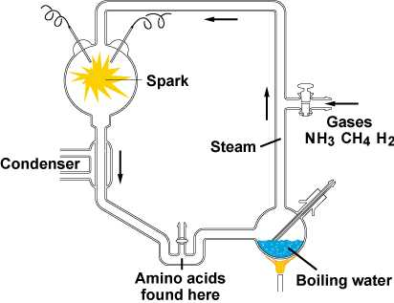 | Abiogenesis  The theory that living things can come from _____________________  Things.  **Disproved!**  Examples:  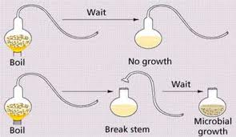  - Louis Pasteur:  - Francesco Redi:  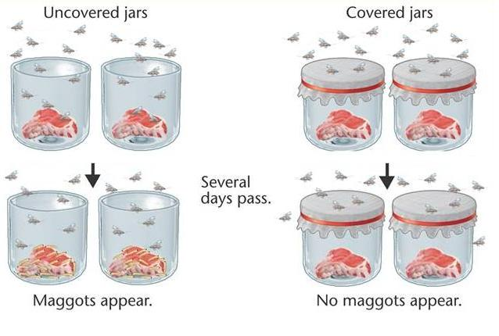

Endosymbiont Theory: Also called _________________________________________________________________.
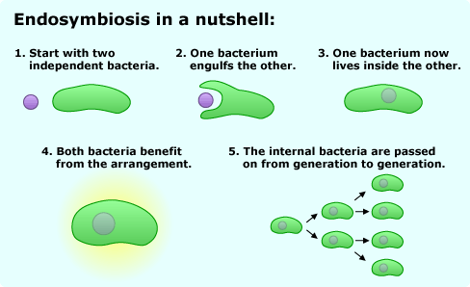

___________________ prokaryotes ___________________ Prokaryotes Photosynthetic __________________ Multicellular Organisms

Evidence of Evolution
- Fossil Evidence
3 types of fossils:

1.

2.

3.

- Biochemical Evidence: Comparing common _________________________________ among organisms. The more amino acids in common, the more closely related.

- Anatomical Evidence:
- _____________________________________: Embryos of various organisms appear very similar
- Homologous Structures: Same _____________________________________, different ___________________________
- ___________________________ structure: Different ________________________, Same ____________________________
- Vestigial Structure: Organs that were useful to an organism’s _____________________________________, but no longer serve a _____________________________________.
Embryology | Homologous Structures | Analogous Structures | Vestigial Structures  Examples:  1.  2.  3.  4.  5.  6.

Speciation
Charles Darwin

- Naturalist  - Sailed to the _______________________________________  - Ship: ______________________________________________  - Book: _____________________________________________ | Observations:  - Finches:  - Tortoise:  - Marine Iguanas:
These observations lead Darwin to the ____________________________________________________________________________________

Natural Selection
A.K.A: Survival _____________________________________________  The process:  - Individuals with ________________________________ survive  - Mate & _____________________________________________  - And pass the desirable trait on to their ___________________________________________________. | 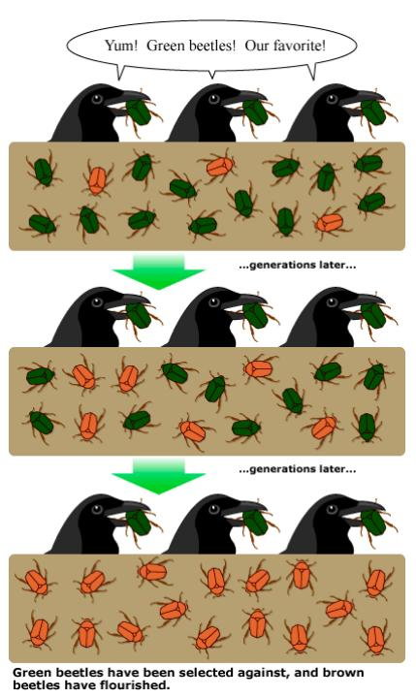
Survival Adaptations:
Mimicry  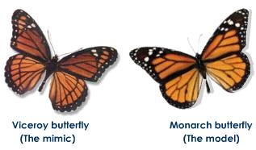 | Camouflage  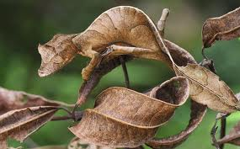

Disease Agents:
Antibiotic Resistance:
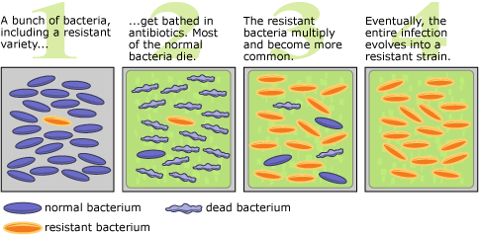

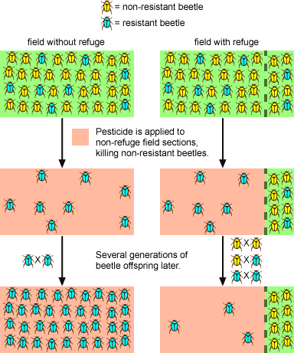
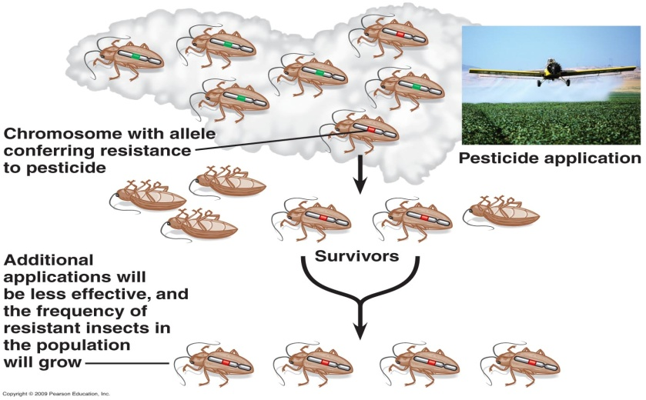
Pesticide Resistance:

Vaccines & Antivirals

Vaccine: ____________________________________ form of a virus given to boost one’s immunity to a disease.
Virus: ______________________________________ pathogen that cannot ________________________________________ without a host cell.

Virus Structure  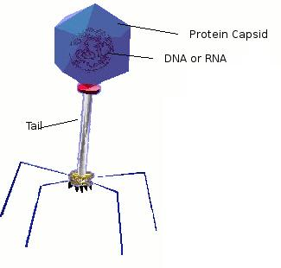 | Virus Life Cycles  Lytic Lysogenic  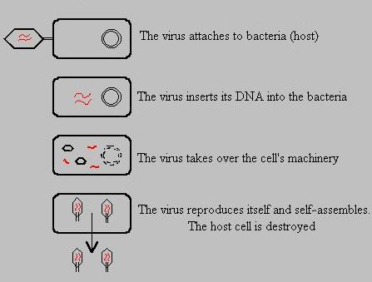  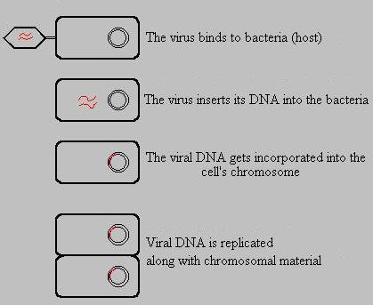

Passive & Active Immunity
Active Immunity  Body makes its own antibodies after becoming infected with a pathogen.  Natural:  Artificial: | Passive Immunity  Body is directly given the antibodies to a pathogen  Natural:  Artificial:
Geographic Isolation:
When a species gets separated from each other due to a geographic feature, the species begins to evolve in order to adapt to the new environment, Eventually the birds will evolve into two genetically different species.
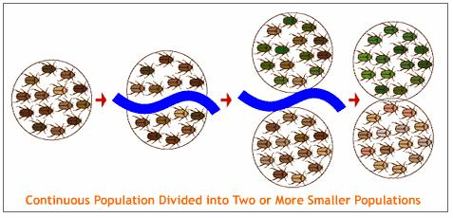

Taxonomy
The science of ______________________________________________________
________________________________________________________________: Putting things into meaningful groups according to likeness.

Aristotle  - First to classify ______________________________________  - He made 2 groups: Blood Vs. Bloodless  (Plant & Animal)  - Classified based on __________________________________ and less on _________________________________________ similarities. | Linnaeus  - Classified based on __________________________________ similarities/form.  - Developed several _________________________________ (groups) for classifying.  - Binomial Nomenclature:  - Giving every organism a ____________________________ Latin name.  - 2 word name - ____________________________________  - Ex. Humans = _____________________________________
Taxa: A category used in classification
(Largest) (Smallest)
Kingdom _____________ Class order ___________________ Genus Species

“_______________________________________________________________________________________________________________”

Kingdoms of Life
Bacteria  - Prokaryotic  - ____________cellular  - Some cell walls are  ___________________  - Some ancient types can live in extreme  ___________________ | Protista  - Eukaryotic  - Auto______________ & hetero______________  - Plant-Like, Animal-Like. & ___________________  - “Junk drawer” Kingdom  - Kingdom of microscopic _____________________ | Fungi  - Cell walls are made of ________________  - Heterotrophic ___________________ | Plant  - Eukaryotic  - Cell walls are made of ________________  - ____________Cellular  - ____________trophic | Animal  - Eukaryotic  - ______________cellular  - Lack a _____________________  - _______________trophic
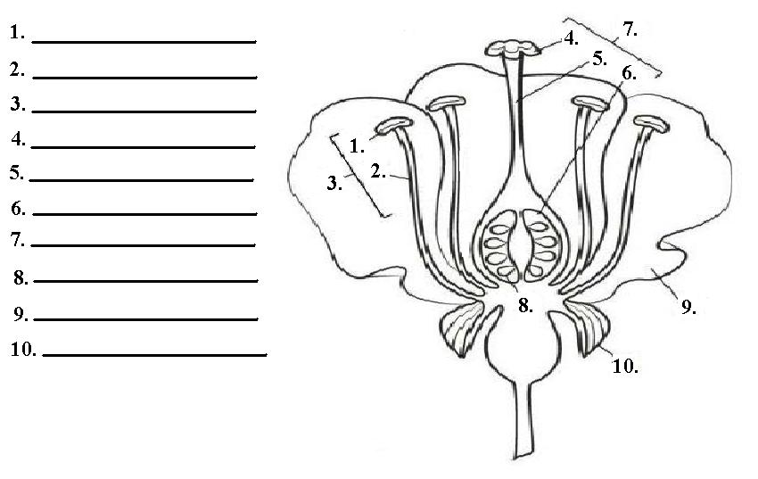
Flower Anatomy

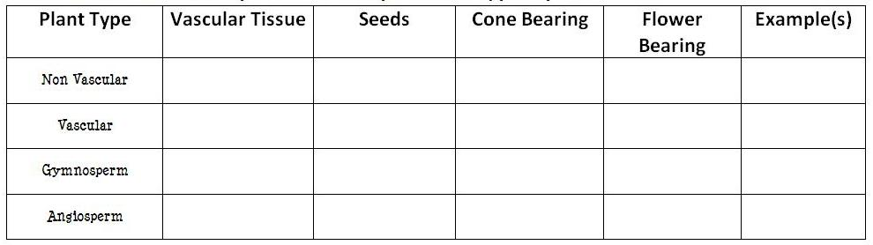

Dichotomous Key

Uses _______________________________________________________ to identify organisms
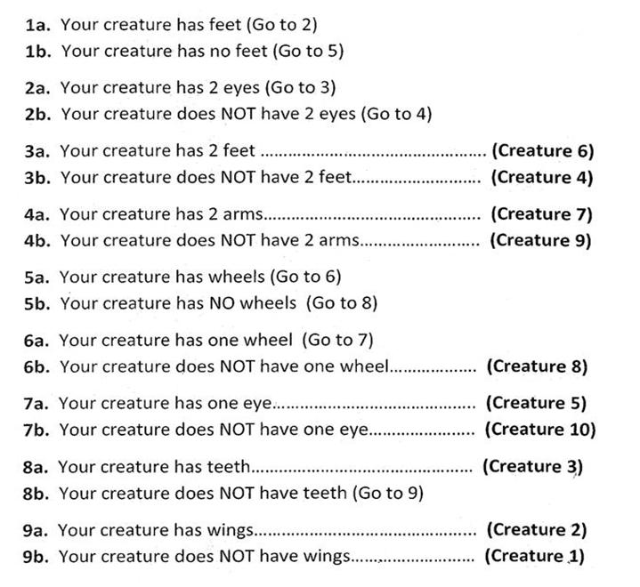
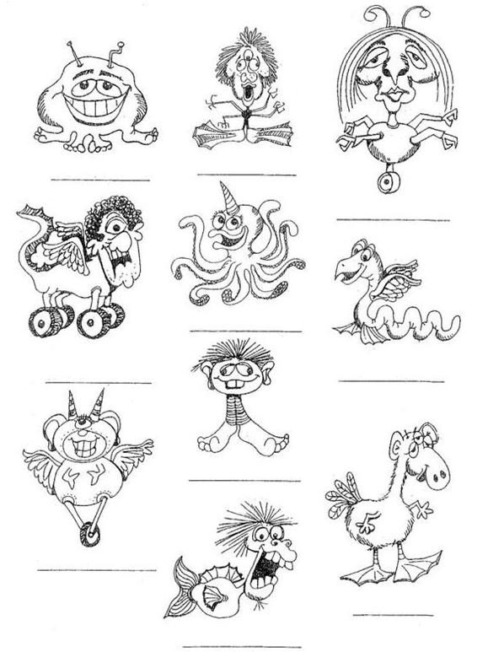
Cladograms
- Also called ______________________________________________________________________
- Shows ___________________________________________________________ among organisms (________________________________)
- Also shows when particular _______________________________________ emerged.
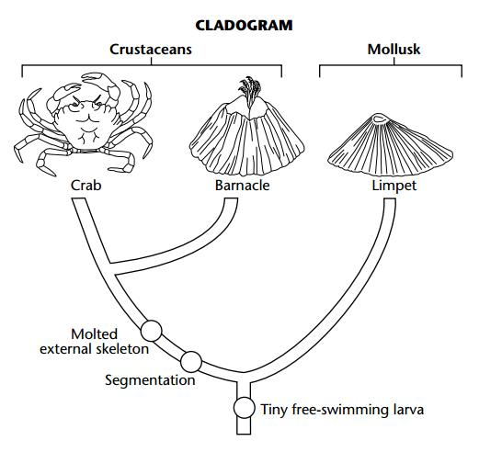 | 