Bio.3.1 Explain how traits are determined by the structure and function of DNA.
Bio.3.1.1 Explain the double-stranded, complementary nature of DNA as related to its function in the cell.
Bio.3.1.2 Explain how DNA and RNA code for proteins and determine traits.
Bio.3.1.3 Explain how mutations in DNA that result from interactions with the environment (i.e. radiation and chemicals) or new combinations in existing genes lead to changes in function and phenotype.

DNA Structure:
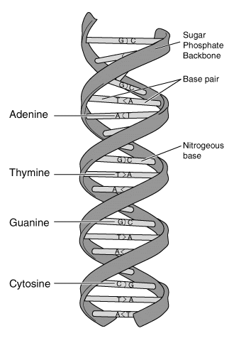  Shape Called:  3 Individuals who studied the shape of DNA:  1.  2.  3.  Backbone  Sides (“backbone”) of DNA are made up repeating:  Name:  Shape:  &  Name:  Shape:  Nitrogen Bases are held together by a  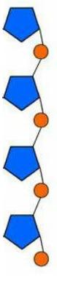 |  |  | 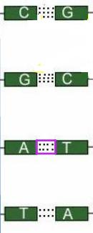  Nitrogen Bases
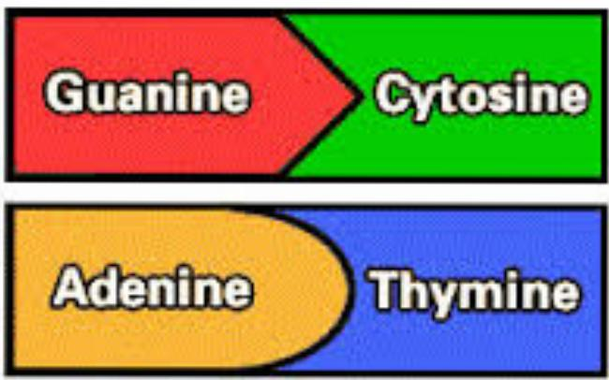
Label the nucleotide:
In a strand of DNA, 15% is composed of thymine. How much of the DNA is Guanine?

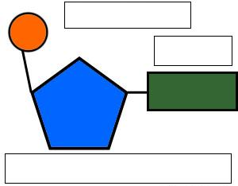
Base Pair Rule:

DNA Vs. RNA
- Structure  DNA is  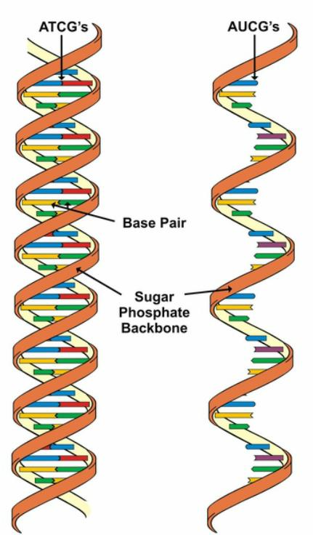  RNA is | - Bases  DNA has  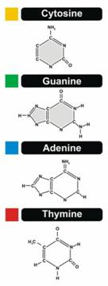  RNA Has  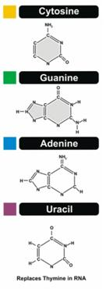 |  |  | - Sugar  DNA has  RNA has  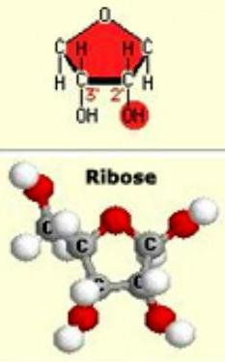  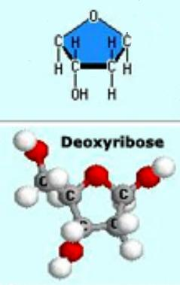
DNA Replication
DNA Replication occurs during:  Because… |  | 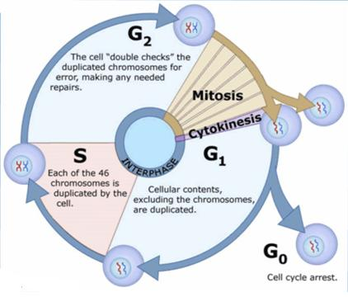
The Process of DNA Replication:
- ________________________________________________  Unzips the DNA  - Nucleotides pair up next to the parent strand forming a _______________________________________________  - 2 new strands of DNA are made; each made of 1 new _________________________________________________ and 1 old parent strand |  | 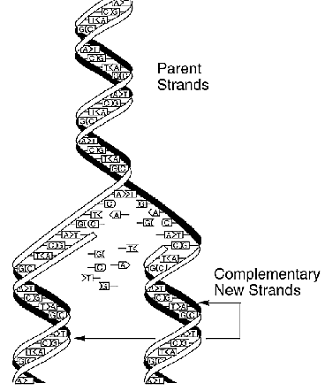
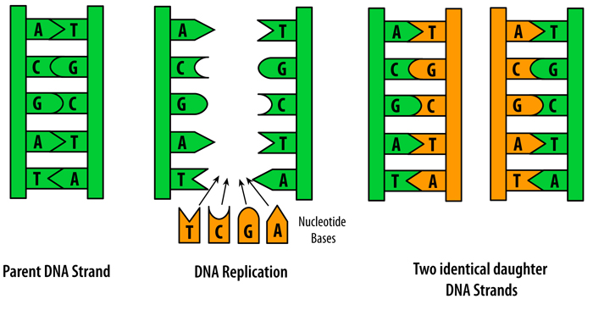

Transcription
- The process by which DNA makes a disposable copy of itself called ____________________________________.  - Occurs in the ____________________________________.  - The strand of mRNA travels to the _____________________ to be translated. |  | 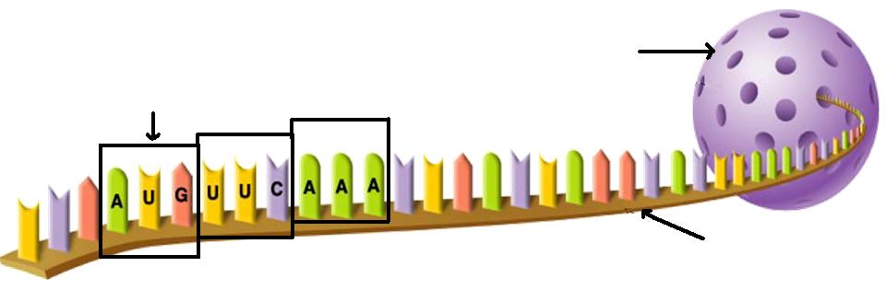
Translation
- The process in which mRNA is read and converted into a protein is called ___________________________________.  - Occurs at the ______________________________________.  (rRNA)  - mRNA is read 3 bases at a time called a _____________________________________.  - Start Codon: ___________________________  - tRNA also contain 3 bases called an _______________________________________.  - When a codon on the mrNA matches an anticodon on the tRNA, the tRNA brings the correct ___________________________________________________ to the ribosome.  - The ribosome links the amino acids together with a strong ___________________________________________ bond.  - This chain of amino acids is called a ________________________________________________, also called a protein! |  | 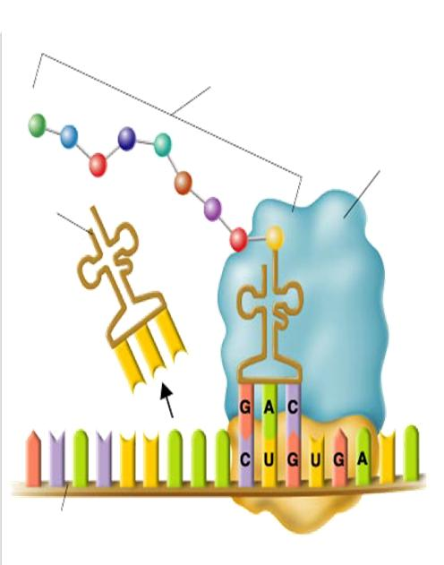  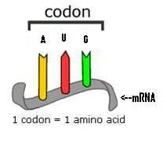  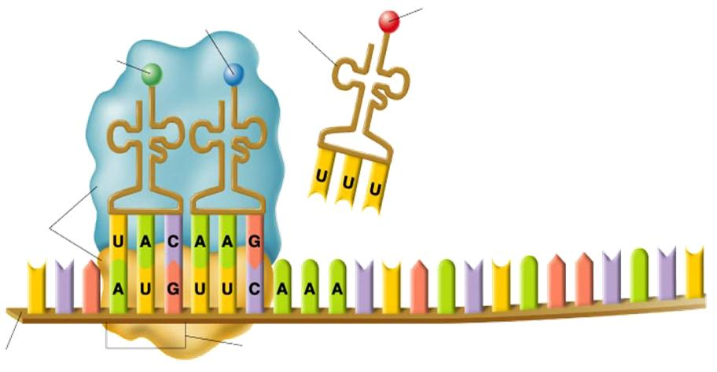  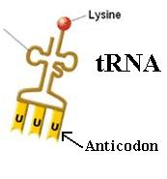
Cells & Their Proteins
Cells respond to their environment by producing different types/amounts of protein. |  | Ex:
All of your cells have the same DNA:  - Some __________________________ get turned on, some get turned off.  - This allows cells to ______________________________________________.  - Phenotypes: |  | Ex:  Cell Type Protein Function  Red Blood Cell  Eye Cells
Activated ________________________________________ Produce specific ________________________________ Specialized Function

Mutations
A change in the base sequence of DNA.
POINT MUTATION |  | FRAMESHIFT MUTATION
A MUTATION AT ONE LOCATION WHERE ONLY ONE AMINO ACID MAY BE PRODUCED INCORRECTLY. |  | A MUTATION THAT CAUSES SEVERAL AMINO ACIDS TO BE PRODUCED INCORRECTLY.
Ex: ___________________________________________________:  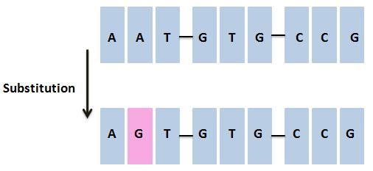 |  | Ex: ______________________________________________________  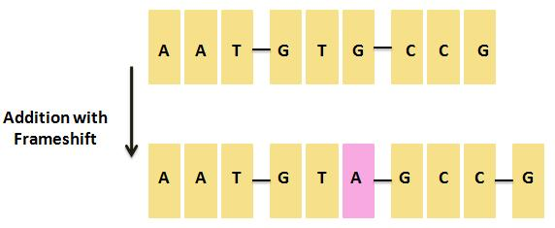  Ex: _______________________________________________________  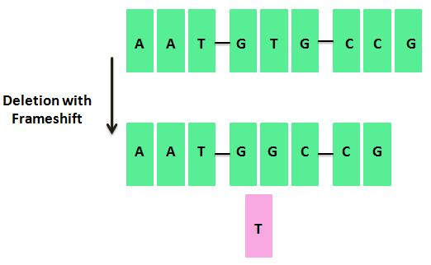
Mutations can be
1.

Or

2.

