Biology Review Sheet
Taxonomy and Overview of the 6 Kingdoms
Questions | Answer
Use Table 17-2 to answer the following question.
Which two animals listed in the chart are the most closely related? Explain.

Use Table 17-2 to answer the following question.
Which two animals listed in the table are the least closely related. Explain.

Use Table 17-2 to answer the following question.
Which kind of animal would a Felis domesticus be?

Use Table 17-2 to answer the following question.
Who developed the type of classification shown in Table 17-2?

Use Table 17-2 to answer the following question.
Which of the classifications shown in Table 17-2 is the most specific?

What is the name given to the diagram that is used to show evolutionary relationships between two organisms called?
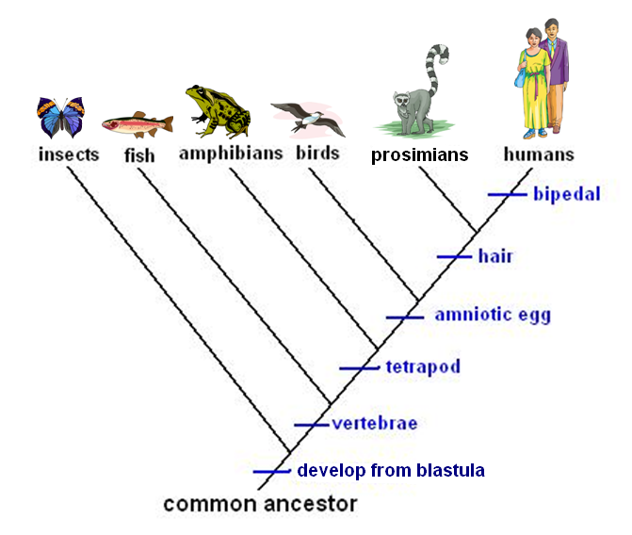
- Which characteristic do ALL of the organisms shown have in common?
- Which animal shown in the diagram above does NOT have a vertebrae?
- According to the diagram above, which organism is most closely related to humans?
- What does the diagram above illustrate?

How many “groups” did Aristotle use in his classification system? What were they?

What was the basis of classification of each of Aristotle’s groups?

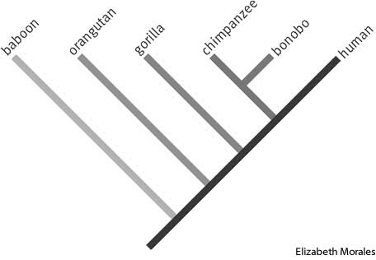
This diagram is called a _______. It is used to illustrate……
What information do scientists use to construct a diagram that depicts the evolutionary history of organisms?
When looking at the scientific name of an organism such as Musca domestica, what does the word Musca indicate?
When looking at the scientific name of an organism such as Musca domestica, what does the word domestica indicate?

Give an example of a scientific name and the common name for a particular organism. You can choose one from Table 17-2.
Is/Does a scientific name….
- Indicate the same information in different parts of the world?
- Consist of two words?
- Have the first word capitalized?
- Have the second word capitalized?
- Written in Latin?
- Have a second word that is in Latin that describes a characterisitic of that organism?

List the seven taxa used by Linnaeus in his classification system from largest to smallest.

Are/do prokaryotic organisms…..
- Mulitcellular or unicellular?
- Contain a nucleus or organelles?
- contain ribosomes?

Describe the organization of the genetic material of a prokaryotic cell.

Describe the organization of the genetic material of a eukaryotic cell.

Describe the cell size of a typical prokaryotic cell. In your description, compare it to a eukaryotic cell.

Describe the cell size of the typical eukaryotic cell. In your description, compare it to a prokaryotic cell.

Are/do eukaryotic organisms…..
- Mulitcellular or unicellular?
- Contain a nucleus or organelles?
- Contain ribosomes?

Describe what binomial nomenclature is.

What is taxonomy?

Who developed the first classification system?

Who developed the classification system that we use today?

What is classification?

Table 17-2
Organism House cat Red fox Dog Wolf Gopher Fly
Kingdom Animalia Animalia Animalia Animalia Animalia Animalia
Phylum Chordata Chordata Chordata Chordata Chordata Arthropoda
Class Mammalia Mammalia Mammalia Mammalia Mammalia Insecta
Order Carnivora Carnivora Carnivora Carnivora Rodentia Diptera
Family Felidae Canidae Canidae Canidae Geomyidae Muscidae
Genus Felis Vulpes Canis Canis Thomomys Musca
Species F. domesticus V. fulva C. familiaris C. lupus T. bottae M. domestica

Cell Type Cell Wall Body Form Nutritution
Eukaryotic Yes Unicellular Autotroph
Prokaryotic No Multicellular Heterotroph
Both Both

Kingdom | Eubacteria | Archaebacteria | Protista | Fungi | Plantae | Animalia
Cell Type

Cell Wall

Body Form

Nutrition

Reproduction

Locomotion

