Biology Review Sheet
Basic Science Skills Unit
Test Date = ___________________________

- What do we call information that we gather during an experiment?
- When you suggest that warm water will melt snow and ice, you have made what type of statement?
- Is/can a hypothesis….
- Ever proven?
- Accepted as correct with being tested with an experiment?
- Be disproven by a single experiment?
- When is a hypothesis useful?

- What is ONE safety rule you should ALWAYS follow?

- How many trials/samples for each experimental group should be tested during an experiment that is using a good experimental design?
- List the steps of the scientific method in order. (Remember Purple Rabbits Have Eating Disorders And Can’t Read)
- Look at the following graduated cylinder. What is the volume?
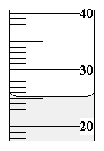

- What is information gathered by using one of the five senses called?

- When we use numbers to describe objects, we are being _______.

- When we use words/descriptions to describe objects, we are being _____.

- What is the act or process of deriving a conclusion based solely on what one already knows called?

- Which variables are…  - Observed to measure a change as a result of the independent variable?  - Graphed on the y-axis?  - Controlled and changed by the person conducting the experiment?  - Graphed on the x-axis? | a.  b.  c.  d
- Use the following diagram to determine whether each statement is an Inference or an Observation.

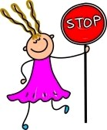

- She is holding a stop sign
- It is windy outside
- She is wearing a dress
- She is happy
- She is working at a cross walk.
- There are four letters on the sign.
- Her mom made her pancakes for breakfast.
- Use the following picture to answer questions differentiating qualitative and quantitative data:
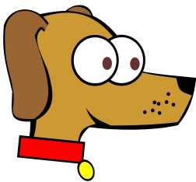
- Fido has big eyes.

- Fido has two eyes.

- Fido has one nose.

- Fido has a long nose.

- Fido has a wide collar

- Use the following data chart to answer the questions listed after the chart:  Number of Baskets Made by FVHS Basketball Team  Group 1 Baskets Made Group 2 Baskets Made  Day 1 55 40  Day 2 58 45  Day 3 62 48  Day 4 62 50  Day 5 65 53  Day 6 66 54  Day 7 69 59  - On which day did Group 1 make 10 more baskets than Group 2?  - On which day did Group 2 make 50 baskets?  - How many days did Group 1 make 62 baskets? | a.  b.  c.
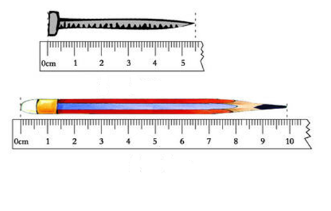

- What is the most accurate reading of the length of the pencil in cm?
- What is the most accurate reading of the length of the nail in cm?
- Should you ever “guess” about what steps you should take during a lab if you are unsure or in doubt about any part of a lab?
- Which piece of lab equipment would you use to measure the mass of an object?
- What unit do we use in Biology when we are measuring mass?

- Which piece of lab equipment is used to most accurately measure volume of a liquid?

- Which part of an “If, then” statement is the independent variable?

- Which part of an “If, then” statement is the dependent variable?

- Review ALL of your vocab words!!!
- What is the use of this piece of lab
equipment?

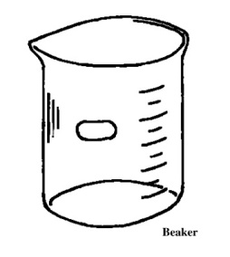

- What is the use of this piece of lab
equipment?
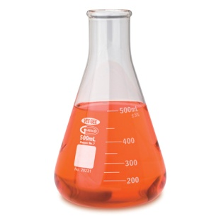

- What is the use of this piece of lab
equipment?
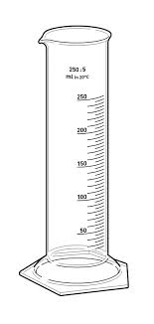
- What is the use of this piece of lab
equipment?
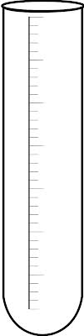
- What is the use of this piece of lab
equipment?
