Biology – Graphing Practice | Name ___________________________________  Date __________________
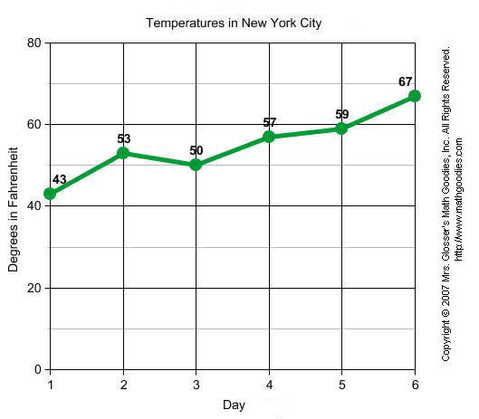
QUESTION
1. | What is the title of this line graph? ______________________________________________
2. | What is the independent variable? ______________________________________________
3. | What is the dependent variable? ________________________________________________
4. | On which day was the lowest temperature recorded? ____________________
5. | What was the highest temperature recorded? _________
6. | On which day did the temperature decline? ___________
7. | On which day did the temperature have the highest increase? _____________

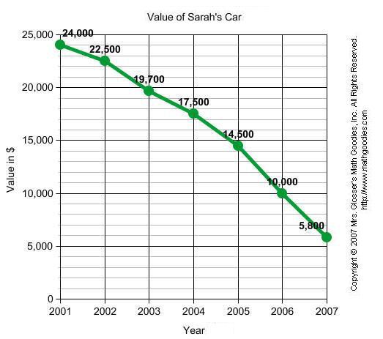
- What is the title of this graph?
___________________________

- What is the dependent variable?
___________________________

- What is the independent variable?
____________________________

- Did the value of Sarah’s car increase or
decrease over time? ________________
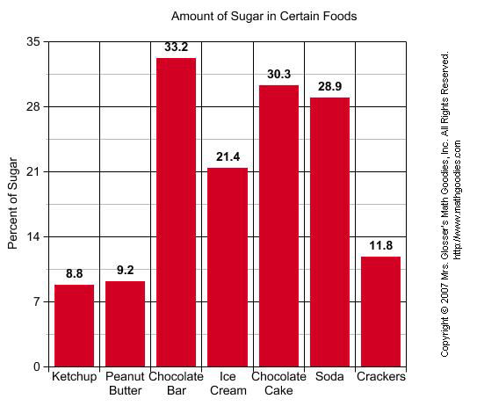

- What is the title of this graph?
_____________________________

- What is the independent variable?
_____________________________

- What is the dependent variable?
_____________________________

- Which food has the highest percentage of
sugar? _____________________

- What food has the lowest percentage of sugar? ___________________

- What is the percentage of sugar in soda? __________________

- What is the difference in the percentage of sugar between ice cream and crackers? __________

- Construct a data table for this graph.

- What should the title of this graph be?
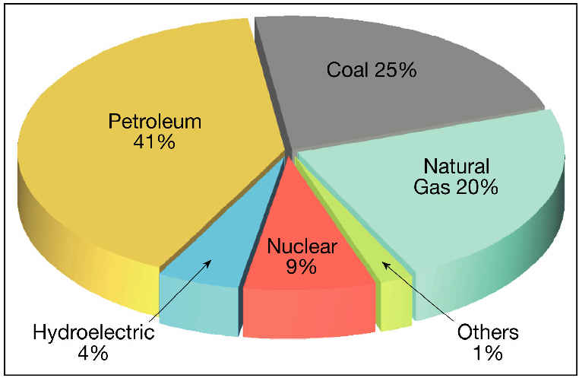
______________________________________

- What source of energy does this particular country use the most? ___________________

- List the sources of energy from least used to the most.

