Part 1: Elements & Compounds / Mixtures & Pure Substances

Name:

- Match each particle diagram (A-H) with its correct description. Questions may have more than one answer.
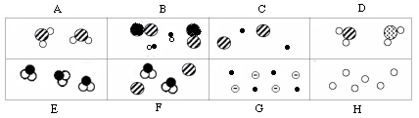

  - a mixture of compounds only ________________
  - a mixture of elements only ________________
  - a pure substance ________________
  - a mixture of elements and compounds ________________

Part 2: Atomic Models

- What important contribution did each scientist below make to our understanding of atoms?
  - Dalton
  - Thomson
  - Rutherford
  - Chadwick
  - Bohr

- Which scientists would have drawn the following pictures to represent their models of the atom?

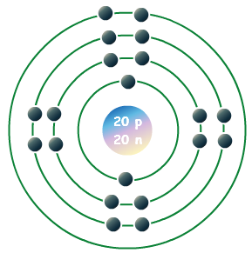 | 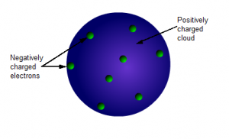 |  | 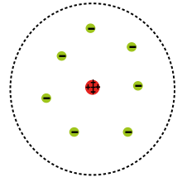

Part 3: Basic Atomic Structure

- Compare and contrast protons, neutrons, and electrons in terms of their (1) location, (2) charge, and (3) relative mass.

- Draw a Bohr model for a neutral atom of fluorine.

- How can an atom be neutral if it contains particles that have positive and negative charges?

Part 4: Isotopes

- Which of the following are isotopes of nitrogen? Circle all that apply.

$${}_{7}^{14}N {}_{6}^{13}N {}_{7}^{15}N {}_{15}^{7}N {}_{13}^{6}N {}_{6}^{14}N {}_{14}^{7}N$$

- According to your answer(s) to the previous question, how are the isotopes of nitrogen alike? How are they different?

- Complete the table below.

Nuclear Symbol | Atomic # | Mass # | # of Protons | # of Neutrons | # of Electrons | Isotope Name
$${}_{14}^{28}{Si }$$
 |  |  | 29 | 35
 |  |  |  |  |  | Bromine-81
$${}_{12}^{25}{Mg}$$
 |  |  |  |  |  | Iron-57
 | 28 | 62

Part 5: Nuclear Reactions

- What is a nuclear reaction?

- Why do radioactive atoms emit radiation?

- What happens when radioactive atoms undergo radioactive decay? What is usually the result?

- Identify the missing particle in the following nuclear reactions and identify the type of nuclear reaction that occurs.

 | Nuclear Equation | Type of Nuclear Reaction
a.
b.
c.
d. | 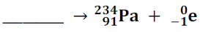
e.

- Which type of radioactive particle is the most dangerous? Why?

- What is the difference between nuclear fusion and fission?

- Which one of the two processes is used in nuclear power plants?

- Which process fuels (occurs in) the Sun and other stars?

- Which process is responsible for forming the first 92 elements on the Periodic Table?

- What is a radioactive half-life?

- Actinium-226 has a half-life of 29 hours. If 100 mg of actinium-226 disintegrates over a period of 58 hours, how many mg of actinium-226 will remain? Show/label your work.

- Thallium-201 has a half-life of 73 hours. If 1.0 mg of thallium-201 remains after a period of 6.0 days and 2 hours, how many mg of thallium-201 were originally in the sample? Show/label your work.

