- Plate Tectonics is a combination of what two theories?

- What is the process by which currents are driven by temperature differences within fluids?
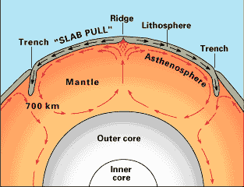
  - As a fluid is heated it…

  - As it rises it ….

- This behavior of fluids creates convection currents in the mantle that are responsible for ________________________________________________.
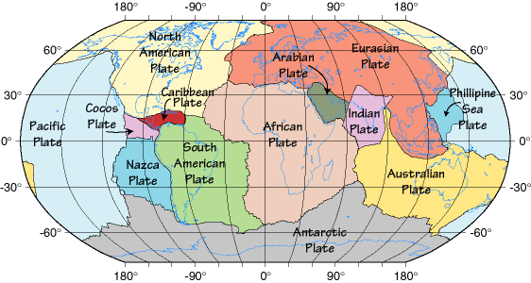
- How does Plate Tectonics describes Earth’s lithosphere?

- How can plate edges be drawn?

- Plates can be made of:

- What is a plate boundary? What happens at plate boundaries?

- 3 Types of plate boundaries: (List the 3 types of convergent boundaries on the next side)

What determines the type of geologic activity that will be found at a plate boundary?

- What is a Rift Valley? What type of plate boundary forms them?

- 3 Types of Convergent Boundaries:

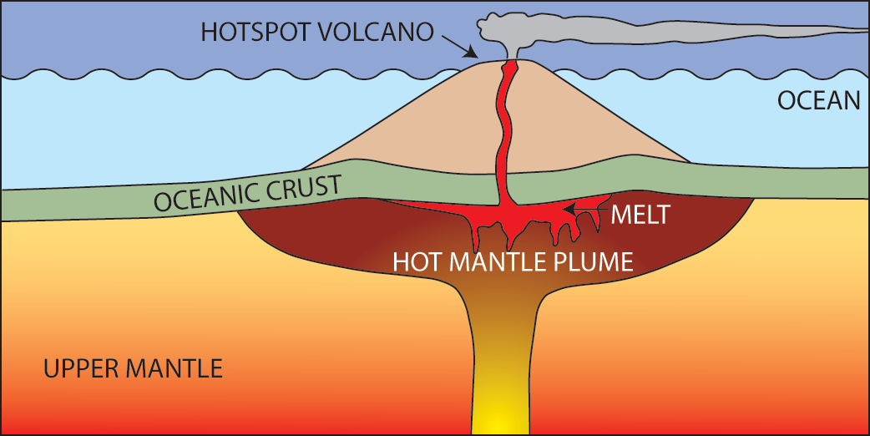
- When does subduction occur?

- What is intraplate activity? How does it form a hotspot?

