Bathymetry  - What is it?  - What do we use it for? | 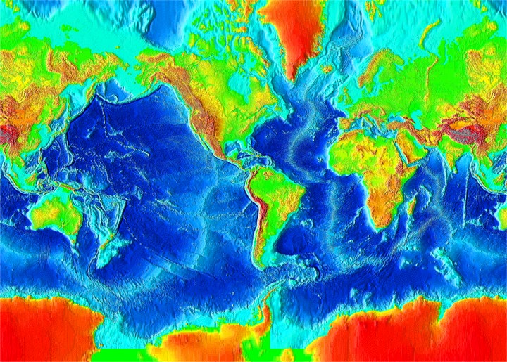
Echo Sounders  - What do they do?  - How do they work? | 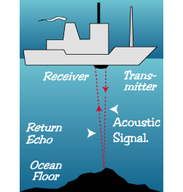
Major Features of the Ocean Floor  - Mid-Ocean Ridges  - Deep Sea Trenches  - Abyssal Plains | 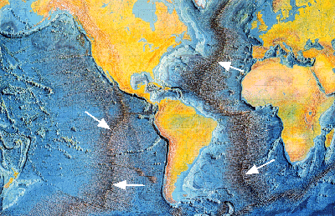
 | 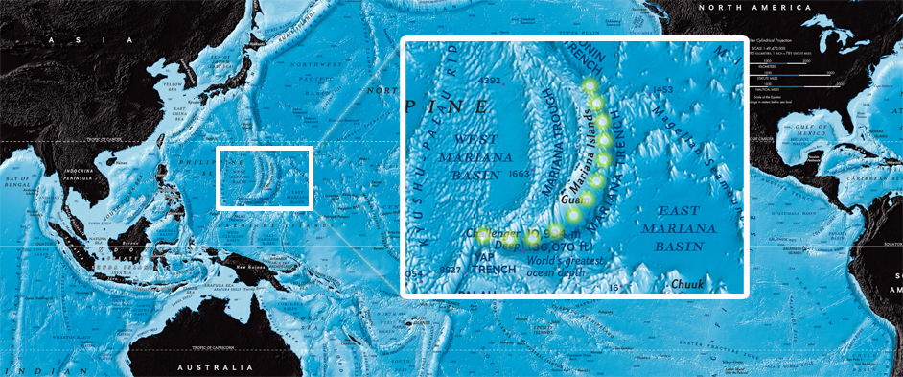
 | 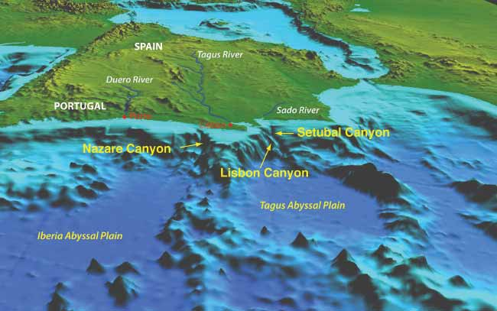
What process formed the main features of the seafloor?
Observations/Evidence  1.  2.  3.  4. | 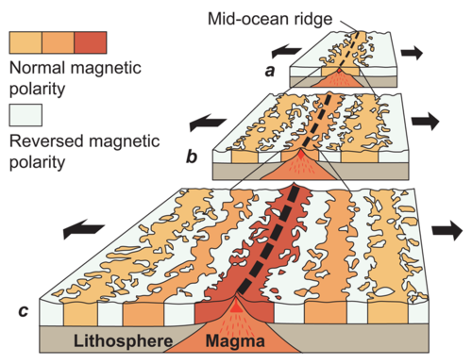
 | 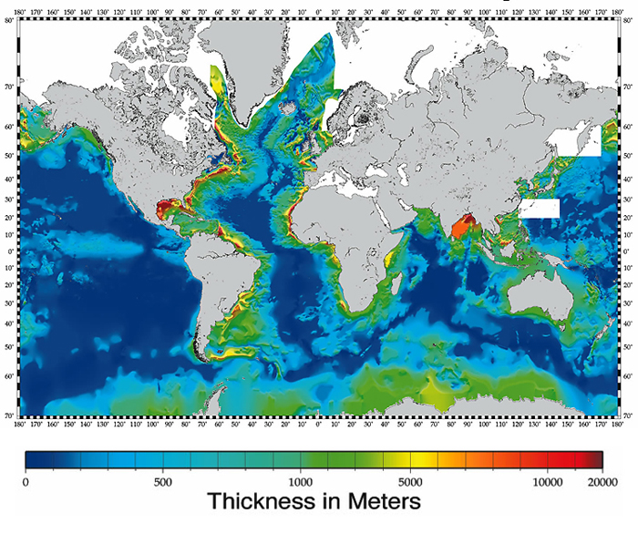
 | 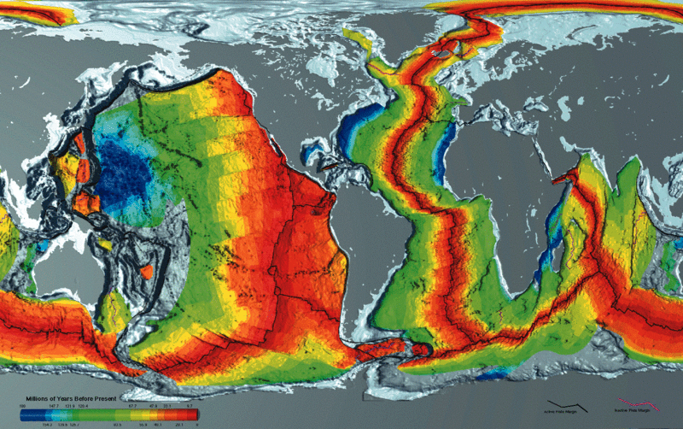
 | 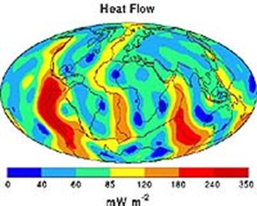
How does Seafloor Spreading Work? | 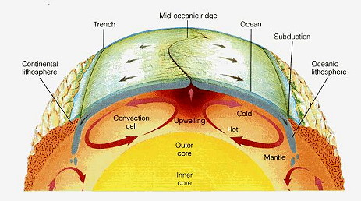
How did Seafloor Spreading support Wegener’s idea of Continental Drift?

