- Who was Alfred Wegener?

- What did Wegener call the “super” continent that included all of Earth’s present day continents?
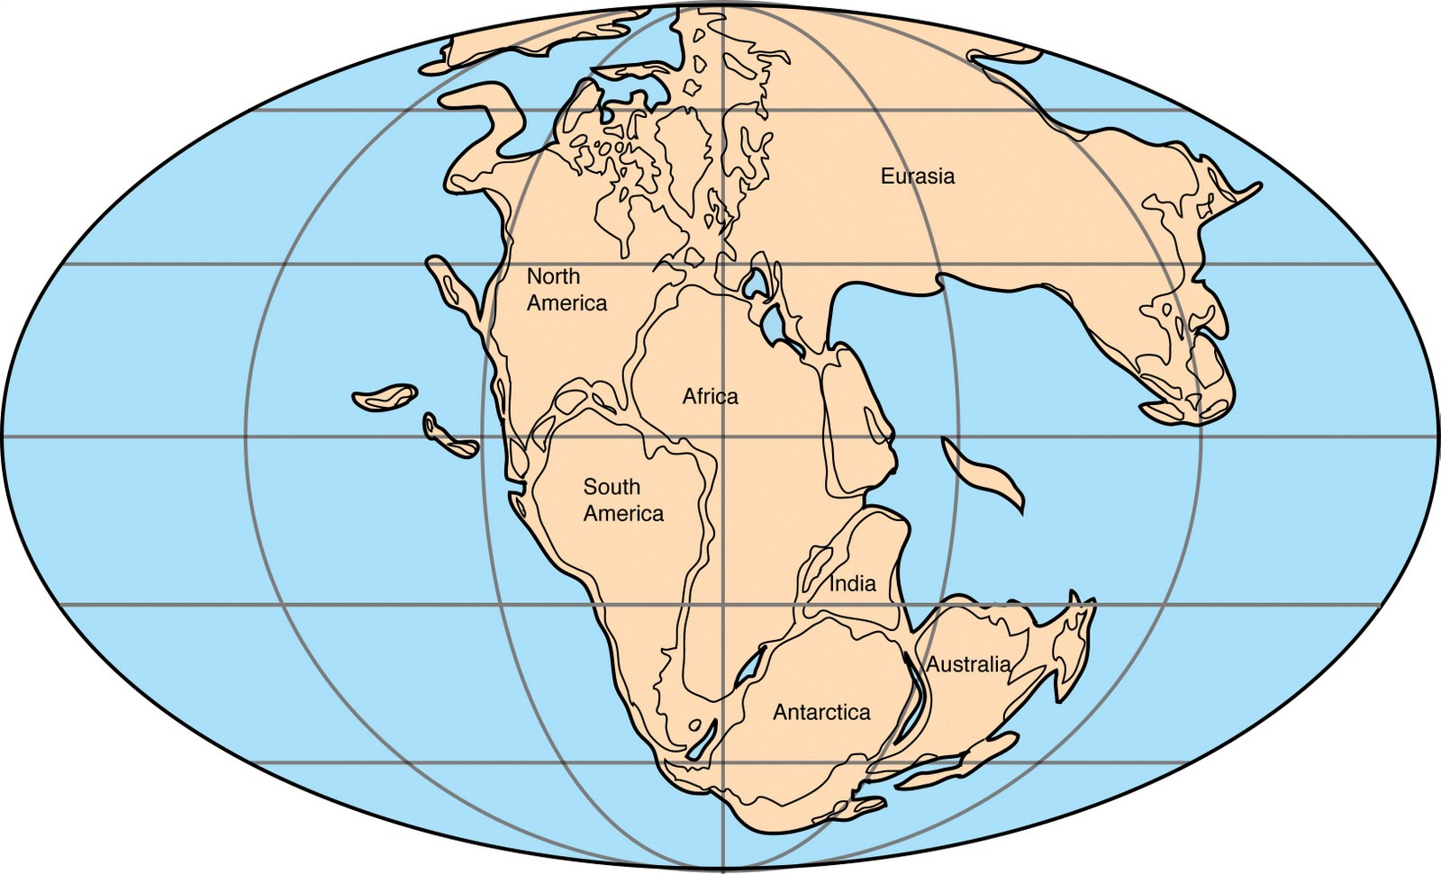

Support for Continental Drift
  - Shape of the Continents

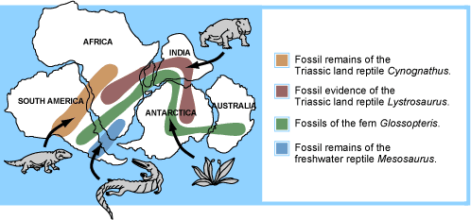
  - Fossil Evidence

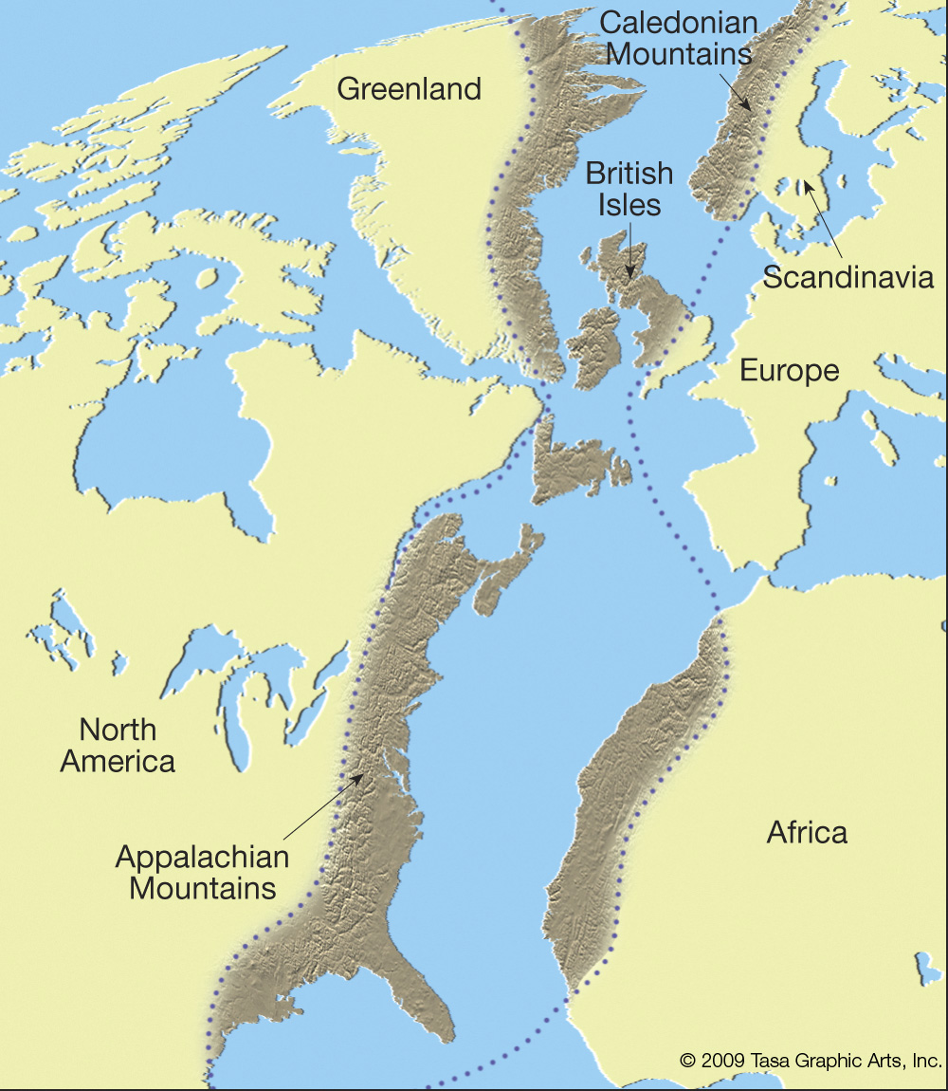

  - Rock Evidence

  - Glacial Scars
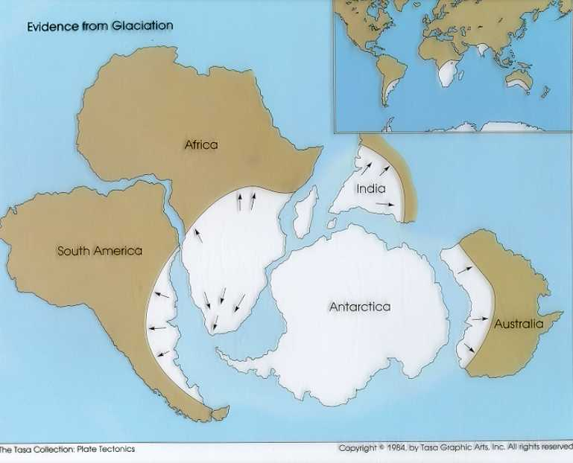

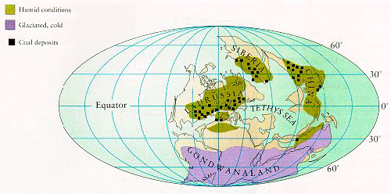
  - Location of Coal Deposits

- Why didn’t people believe in Continental Drift?

