Spheres of the Earth Collage Project.

Purpose: Create a collage representing the four spheres of the Earth through clippings from magazines and internet.

Directions:

1. Obtain four pieces of computer paper and join them together using tape or glue.
2. Draw four connecting circles, each with a diameter of 20 centimeters.
- Label the circles: Hydrosphere, Atmosphere, Lithosphere, & Biosphere. Color the circles with color pencils in the following format.
- Biosphere = Green
- Hydrosphere = Dark Blue
- Atmosphere = Light Blue
- Lithosphere = Red
- Next write words of things that one would see in the natural world inside of the areas that are overlapping. Example: Where the Hydrosphere and the Biosphere meet, write names of organisms that would belong there. Try to fill the areas up with examples that you and your group think of.
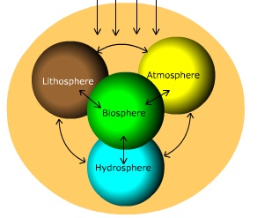

3. On the opposite side (white) find colorful clippings from magazines or the internet that represent each sphere. Example: trees, animals, mountains, etc.

4. Glue pictures within the circles. The entire circle should be filled with pictures.

5. Parts of the circles will connect with each other. In those areas find clippings that are able to represent both/all of the spheres that connect.

Reminder: Make sure clippings are carefully cut out and not ripped. Please fill the circles completing with pictures (no paper showing.)

