What are the three types of systems? What are examples of each type?

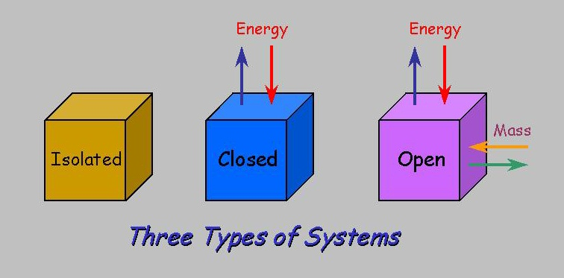

- What are the 4 spheres of the Earth?

  - Atmosphere:
- Mixture of:
- Extends:
- Why are O₂ , CO₂ , and O₃ important?

  - Lithosphere:

  - Hydrosphere:

  - Biosphere:

- How do Earth’s spheres interact?

- How many parts of the Earth system can you identify in this image? How do they interact?
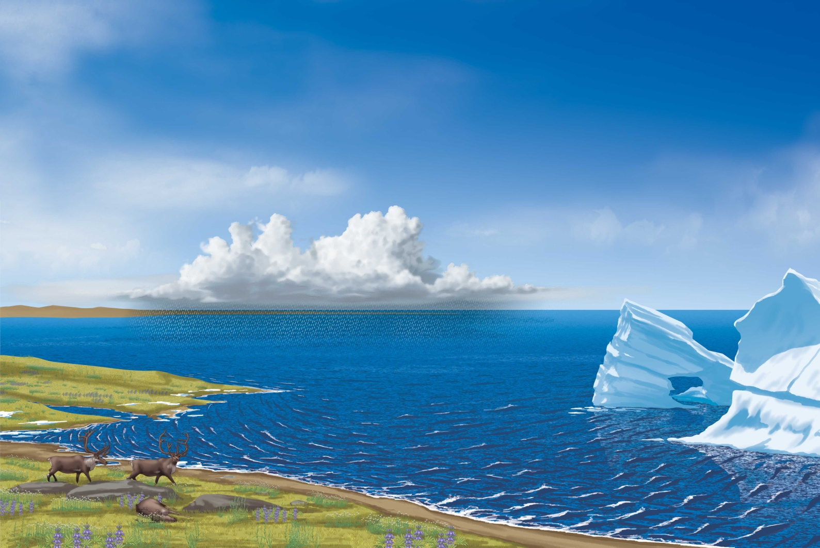

Biosphere 2 – Video Questions
- What was the original intent for Biosphere 2?

- How is it currently used?

- Who now owns Biosphere 2?

- How is Biosphere 2 being used to study the rainforest?

- What type of system is Biosphere 2?

