1. What are elements?

* All matter is made of elements
* 92 naturally occurring elements on Earth
* Elements are made up of atoms.

1. What makes up an atom?

* Nucleus:
* Protons:

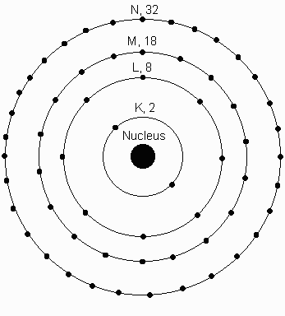

* Neutrons:
* Electrons:

1st energy level:

2nd energy level:

3rd energy level:

Atomic Number:

* There are an equal number of protons & electrons in a neutral atom

Atomic Mass:

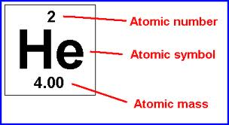

* The number of neutrons can vary in an tom, but the protons will

ALWAYS be equal to the atomic number.

Isotope Notation:

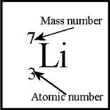

How to determine Atomic Number and Mass Number

1. If you are not given the atomic number, simply look at the periodic table.
2. If you are not given the mass number….

|  |  |  |  |  |  |  |
| --- | --- | --- | --- | --- | --- | --- |
| **Name** | **Symbol** | **Atomic #** | **Mass #** | **# of Protons** | **# of Neutrons** | **# of Electrons** |
| **Sodium** |  |  |  |  |  |  |
|  | **Br** |  |  |  |  |  |

* How many protons are there in Lithium-7?
* How many neutrons are there in Lithium-7?
* How many protons are there in Mg?
* How many electrons are there in Mg?



* How many neutrons are there in ?
* How many neutrons are there in Oxygen-18?

Isotopes:

* Have different mass numbers
* Isotopes behave the same chemically because they still have the same number of protons and electrons.

Ions:

* So far, we have focused on neutral atoms
  + Which have an equal number of protons and electrons
* We know the protons are tightly held in the nucleus
  + Held there by nuclear forces
* Electrons are scattered outside the nucleus
  + Less restricted and able to change
  + When an atom gains or loses electrons, it is called an ION.

|  |  |
| --- | --- |
| Gains Electrons | Loses Electrons |

|  |  |
| --- | --- |
| Particle Changed | Result |
|  |  |
|  |  |
|  |  |

**Normal: Atomic Mass _______**

**Chlorine has ________ # of protons _________ # of Neutrons _________ # of Electrons**

**Isotope: Atomic Mass 37**

**________ # of protons _________ # of Neutrons _________ # of Electrons**

Atom Bonding

Valence Electrons:

* Atoms bond with each other according to the number of valence electrons *in order to be stable.*
* *Stable atom=*

**Chemical Bonds**

|  |  |  |
| --- | --- | --- |
| **Ionic Bonds** | **Covalent Bonds** | **Hydrogen Bonds** |